C:\Documents and Settings\julia.powell\My Documents\IHO TSMAD\S100-0 main\IHO S-100 Main Oct 1 2007.doc © ISO/IEC 2007 – All rights reservedISO-IEC_ 63Complementary elementIntroductory element — Main elementÉlément introductif — Élément central — Élément complémentaireIntroductory element — Main element — Complementary elementE2007-10-2 ISO/IECISO/IEC     2007 ISO/IEC ISO/IEC _(E).        2Heading 2Heading 1    02 STD Version 2.1c20   4            **INTERNATIONAL HYDROGRAPHIC ORGANIZATION**



**MARITIME LIMITS AND BOUNDARIES**

**PRODUCT SPECIFICATION**

**IHO Publication S-121**

**Edition 1.0.0 – February 2019**

Published by the

International Hydrographic Organization

4b quai Antoine 1er

Principauté de Monaco

Tel: (377) 93.10.81.00

Fax: (377) 93.10.81.40

E-mail: [info@iho.int](mailto:info@iho.int)

Web: [www.iho.int](http://www.iho.int)

|  |
| --- |
| © Copyright International Hydrographic Organization 2019 |
| This work is copyright. Apart from any use permitted in accordance with the [Berne Convention for the Protection of Literary and Artistic Works](http://www.wipo.int/treaties/en/ip/berne/trtdocs_wo001.html) (1886), and except in the circumstances described below, no part may be translated, reproduced by any process, adapted, communicated or commercially exploited without prior written permission from the International Hydrographic Organization (IHO). Copyright in some of the material in this publication may be owned by another party and permission for the translation and/or reproduction of that material must be obtained from the owner. |
| This document or partial material from this document may be translated, reproduced or distributed for general information, on no more than a cost recovery basis. Copies may not be sold or distributed for profit or gain without prior written agreement of the IHO Secretariat and any other copyright holders. |
| In the event that this document or partial material from this document is reproduced, translated or distributed under the terms described above, the following statements are to be included: |
| *“Material from IHO publication [reference to extract: Title, Edition] is reproduced with the permission of the IHO Secretariat (Permission No ……./…) acting for the International Hydrographic Organization (IHO), which does not accept responsibility for the correctness of the material as reproduced: in case of doubt, the IHO’s authentic text shall prevail. The incorporation of material sourced from IHO shall not be construed as constituting an endorsement by IHO of this product.”* |
| *“This [document/publication] is a translation of IHO [document/publication] [name]. The IHO has not checked this translation and therefore takes no responsibility for its accuracy. In case of doubt the source version of [name] in [language] should be consulted.”*  The IHO Logo or other identifiers shall not be used in any derived product without prior written permission from the IHO Secretariat. |

Document Control

Changes to this Product Specification are coordinated by the IHO S-121 Project Team (S-121PT) which is a subsidiary group of the S-100 Working Group (S-100WG). New editions will be made available via the IHO web site.

|  |  |  |  |
| --- | --- | --- | --- |
| **Edition Number** | **Date** | **Author** | **Purpose** |
| Draft 1 | April 2014 | GA Australia | Initial Draft. |
| Draft 2 | 7 Nov 2016 | CHS Canada | Revise BAUnit relationship. |
| Draft 2.2 | 23 Nov 2016 | CHS Canada | Revise spatial relationships. |
| Draft 2.3.7 | 27 Nov 2016 | CHS Canada | Overall review. |
| Draft 3 | March 2017 | CHS Canada | Restructuring as recommended by S-121 Project Team meeting Dec 16. |
| Draft 4 | November 2017 | CHS Canada | Restructuring as recommended by S-121 Project Team meetings. |
| Draft 5 | March 2018 | CHS Canada | Restructuring as recommended by S-121 Project Team meeting Dec 17 and editorial meetings. |
| Draft Edition 1.0.0 | April 2018 | S-121PT | Approved by HSSC 10 under the new review cycle for testing. (Reference; HSSC10/16) |
| Draft Edition 1.0.0 | January 2019 | S-121PT | Minor revision after S-121 Project Team meeting December 2017, including alignment with S-100 Spatial Attribute, changes of optionality on some attributes and acceptance of Encoding Document by UN DOALOS. |
| Edition 1.0.0 | February 2019 | IHO Sec | Revised format and structure. |

TABLE OF CONTENTS

1 Overview 2

1.1 Scope 2

1.2 Conformance Clause 2

1.3 Normative References 2

1.4 Terms, Definitions and Abbreviations 2

1.4.1 Use of Language 2

1.4.2 Terms and Definitions 3

1.4.3 Abbreviations 3

1.5 S-121 General Data Product Description 4

1.6 Data Product Specification Metadata 5

1.7 Product Specification Maintenance 6

1.7.1 Introduction 6

1.7.2 New Edition 6

1.7.3 Revision 6

1.7.4 Clarification 7

1.7.5 Version numbers 7

2 Specification Scope 7

3 Dataset Identification 7

4 Data Content and Structure 9

4.1 Introduction 9

4.2 Application Schema 9

4.2.1 Feature Catalogue 9

4.2.2 Dataset types 9

4.2.3 Object identifiers 10

4.2.4 Geometry 10

5 Coordinate Reference System (CRS) 12

5.1 Horizontal reference system 12

5.2 Vertical coordinate reference system 12

5.3 Temporal reference system 12

5.4 Coordinate reference system registry 12

6 Data Quality 13

6.1 Introduction 13

6.2 Completeness 13

6.2.1 Redundant or oversampled data 13

6.2.2 Omission 13

6.3 Logical consistency 14

6.3.1 Conceptual consistency 14

6.3.2 Domain consistency 14

6.3.3 Format consistency 14

6.3.4 Topological consistency 14

6.4 Positional accuracy 14

6.4.1 Absolute external positional accuracy 14

6.5 Temporal accuracy 15

6.6 Thematic accuracy 15

6.6.1 Thematic classification correctness 15

6.6.2 Non-quantitative attribute accuracy 15

6.6.3 Quantitative attribute accuracy 15

6.7 Dataset Validation checks 15

7 Data Capture and Classification 15

8 Maintenance 16

8.1 Maintenance and Update Frequency 16

8.2 Data Source 16

8.3 Production Process 16

9 Portrayal 16

10 Data Product Format (encoding) 16

11 Data Delivery 17

12 Metadata 17

Appendix A. Abstract Test Suite and Conformance Classes 19

A 1. Test case for attribute assignment to feature classes 19

A 2. Test case for attribute domains 19

A 3. Test case for UUID 19

A 4. Test case for data completeness 19

A 5. Test case for feature commission 20

A 6. Test case for omission 20

A 7. Test case for domain consistency 20

A 8. Test case for format consistency 21

A 9. Test case for topological consistency 21

A 10. Test case for data accuracy 21

Appendix B. Use Case Description 23

B 1. Overview 23

B 2. Use Cases 24

Appendix C. Application Schema 27

C 1. Overview 27

C 2. Feature and Attribute Structure from S-100 27

C 2.1. Application Schema General Model 27

C 2.2. Basic Administrative Unit Package 28

C 2.3. Feature Unit 29

C 2.4. Geometry / Additional Spatial Information 31

C 2.5. Party Unit Package 39

C 2.6. Rights, Responsibilities and Restrictions (RRR) Administrative Package 39

C 2.7. Governance Object 40

C 2.8. Versioned Object 42

C 2.9. Implementation Model 43

Appendix D. Bibliography 47

Page intentionally left blank

**Introduction**

This Product Specification provides a conceptual description of the real world entities (both physical and social) that constitute Maritime Limits and Boundaries (MLB). The MLB conceptual schema is based on S-100 Part 1 - Conceptual Schema Language. The MLB Product Specification also documents the features, attributes, code lists and enumerated lists (and their relationships) required to encode MLB objects for use in geospatial information systems.

When implemented in a geospatial system or as part of an MSDI, the MLB model is sufficiently comprehensive to support the provision of multiple products and services. These may include for example, the deposited of a national maritime boundary claims or the generation of maritime boundary objects for inclusion in S-57 and S-101 Electronic Nautical Charts.

S-121 Annex 1 – “Explicit Text Encoding Format and Implementation Specification” documents the default encoding for depositing MLB claims to the UN DOALOS. Other encoding formats such as the default S-100 GML or ISO8211 encodings, or other proprietary GIS formats may be used for other requirements such as exchange between parties. These will be documented as separate Annexes to the Product Specification document as and when required.

# Overview

The S121 is a product specification for Maritime Limits and Boundaries for the administration of the marine domain. Its data model allows for the description of marine areas, as defined by the UN Convention on the Law of the Sea (UNCLOS), and their associated rights, restrictions and responsibilities while also allowing States to represent generic objects as necessary. Its exchange formats will assist States Parties in meeting their depository obligations under UNCLOS, as well as other legal declarations; and will support integration with other S-100 based products. The standard is based on S-100 and also on the ISO standard 19152 Land Administrative Domain Model.

## Scope

This document describes a product specification for the administration of maritime limits and boundaries in support of the deposit by States Parties of the geographical coordinates of points identifying their baselines and outer limits of maritime zones in accordance with UNCLOS, and other technical and legal requirements. This Product Specification complies with the IHO S-100 Universal Hydrographic Data Model.

## Conformance Clause

Any data set claiming conformance with this Product Specification shall pass the requirements described in the abstract test suites in Appendix A.

## Normative References

The following referenced documents are indispensable for the application of this document.

S-100 IHO Universal Hydrographic Data Model, Edition 4.0.0

ISO 3166-1:2013 Codes for the representation of names of countries and their subdivisions – Part 1: Country codes

ISO 19107: 2003 Geographic Information – Spatial Schema

ISO 19108: 2002 Geographic Information – Temporal Schema

ISO 19115: 2003 Geographic Information – Metadata[1]

ISO 19152: 2012 Geographic Information – Land Administration Domain Model (LADM)

## Terms, Definitions and Abbreviations

### Use of Language

Within this document:

* “Must” indicates a mandatory requirement.
* “Should” indicates an optional requirement, that is the recommended process to be followed, but is not mandatory.
* “May” means “allowed to” or “could possibly”, and is not mandatory.

### Terms and Definitions

For the purposes of this document, the following terms and definitions apply.

**Attribute**

Named property of an entity. For example, number of lanes or pavement status. [ISO 19115-2:2009 from ISO/IEC 2382-17:1999]

In UML “a classifier that describes a range of values that instances of the classifier may hold.” [ISO/TS 19103:2005 – adapted from ISO/IEC 19501]

**Class**

Description of a set of **objects** that share the same attributes, operations, methods, relationships, and semantics. [ISO/TS 19103:2005 – adapted from ISO/IEC 19501]

NOTE A class does not always have an associated geometry (for example, address range class).

**Dataset**

Identifiable collection of data. [ISO 19101:2002 from ISO 19115-1:2014, 4.3]

**Feature**

Abstraction of real-world phenomena. [ISO 19101-1:2014 from ISO 19101:2002]

**Object**

An object is an instance of a **class**.

In UML “entity with a well-defined boundary and identity, which encapsulates state and behaviour.” [ISO/TS 19103:2005 – adapted from ISO/IEC 19501]

### Abbreviations

CEDA Category of Estimated Data Accuracy

CMAS Circular Map Accuracy Standard:

CRS Coordinate Reference System

DOALOS Division of Ocean Affairs Law of the Sea, Office of Legal Affairs, United Nations

EEZ Exclusive Economic Zone

EPSG European Petroleum Survey Group

GIS Geographic Information System

GML Geography Markup Language (ISO standard 19136:2007)

ID Identifier

IHO International Hydrographic Organization

ISO International Organization for Standardization

KML Keyhole Markup Language

LADM Land Administration Domain Model

MLB Maritime Limits and Boundaries

MSDI Marine Spatial Data Infrastructure

UNCLOS United Nations Convention on the Law of the Sea

UML Unified Modeling Language

UUID Universal Unique Identifier

WMS Web Mapping Service

## S-121 General Data Product Description

**Title:** IHO S-121 - Maritime Limits and Boundaries Product Specification

**Abstract:** This document describes a product specification for Maritime Limits and Boundaries (MLB) data as part of the suite of IHO S-100 standards. The purpose is to establish a framework of sourced and versioned objects for communicating in a digital form the geographic extents of marine areas and the associated rights and restrictions that apply to them as well as to provide a flexible and expandable framework able to support other maritime delimitation requirements such as defining areas of overlapping jurisdiction and Joint Development Areas, or any other maritime management areas. This product specification is also compatible with the ISO 19152 Land Administration Domain Model (LADM) structure. This integration bridges both the land and maritime domain structurally and provides to the S-100 series a product specification which effectively supports the description of objects defined in national legislation.

In this product specification, Locations, Limits and Zones are considered features. Zones may be defined by several limit objects and limit objects may be shared between different adjacent zones.

Datasets that conform to this Product Specification comply with one of the conformance classes defined in Appendix A.

**Spatial Extent:**

**Description:** This product specification applies to the maritime area, the discrete boundaries of which are described as an instance of the ISO Metadata element EX_Extent as an EX_GeographicBoundingBox. The area of applicability are the global marine areas.

**East Bounding Longitude:** 180°

**West Bounding Longitude:** -180°

**North Bounding Latitude:** 90°

**South Bounding Latitude:** -90°

**Content Description**

The IHO S-121 - Product Specification for Maritime Limits and Boundaries contains a set of MLBs expressed as set of features compliant with the IHO S-100 Universal Hydrographic Data Model. A number of new feature types and attributes have been defined with their definitions taken from UNCLOS. The features and attributes used in this product specification are described in a separate document and are registered in the IHO Geospatial Information Registry.

The product specification also includes metadata derived from both S-100 and from ISO 19115:2003 Geographic Information – Metadata. In addition to general discovery metadata and descriptive metadata, there are metadata elements used to describe the quality of the data.

**Specific Purpose**

The purpose of this product specification is:

1. The establishment of a data model that supports the description in a digital form the geographic extents of marine areas and
2. The associated rights and restrictions that apply to them
3. To provide a flexible and extensible framework able to support other maritime delimitation requirements such as defining areas of overlapping jurisdiction and Joint Development Areas, or any other management areas.

Built on top of the data model structuring the information, there is a need for several encodings (exchange formats) to support key usages:

(1) MLB features may be used as a source for some elements of navigation products such as ENC (IHO S-57 or IHO S-101).

(2) A separate encoding would be needed for a stand-alone MLB product or the use of MLB objects within a Marine Cadaster.

(3) This standard also establishes a structured text record oriented exchange format that is readable and comprehensible by both the human eye and a computer. This exchange format is designed to support the description of legal aspects of the MLB features in a manner so that they can easily be presented in a court or other legal venue. This data needs to look similar to the current text in treaties and laws. This human readable format is the encoding required to facilitate the States Parties’ deposit obligations under UNCLOS.

## Data Product Specification Metadata

This information uniquely identifies this Product Specification and provides information about its creation and maintenance

|  |  |  |  |
| --- | --- | --- | --- |
|  | **Item Name** | **Description** | **Content** |
| 1 | Title | Title of the data Product Specification. | IHO S-121 - Product Specification for Maritime Limits and Boundaries |
| 2 | S-100 version | The version of S-100 upon which the product is based. | Version 4.0.0 |
| 3 | Product specification version | Version of the Product Specification. | Version 1.0.0 |
| 4 | Date | Date the Product Specification was created / last updated. | May 2019 |
| 5 | Language | Language(s) of the data Product Specification, for example translations. | English (this does not exclude instances of data being encoded in multiple languages). |
| 6 | Classification | Security classification code on the data Product Specification. | The default value is “unclassified” however any value from the code list MD_ClassificationCode may be used, see clause 3. |
| 7 | Contact | Party responsible for the data Product Specification. | International Hydrographic Organization 4b quai Antoine 1er B.P. 445 MC 98011 MONACO CEDEX  Telephone: +377 93 10 81 00 Telefax: + 377 93 10 81 40 Email: info@iho.int |
| 8 | URL | Online-address where the resource is downloadable. | <http://www.iho.int> |
| 9 | Identifier | Persistent unique identifier for a published version of the Product Specification. | S-121 |
| 10 | Maintenance | Description of the maintenance regime for the Product Specification. | Changes to the Product Specification S-121 are coordinated on a needs basis by the S-121 Project Team (S-121PT), a Project Team under the IHO S-100 Working Group (S-100WG), and must be made available via the IHO web site. Maintenance of the Product Specification must conform to IHO Technical Resolution 2/2007, as amended. |

***Table 1‑1 – Data Product Metadata***

## Product Specification Maintenance

### Introduction

Changes to S-121 will be released by the IHO as a New Edition, a revision, or as a document that includes clarifications. These are described below.

### New Edition

*New Editions* introduce significant changes. *New Editions* enable new concepts, such as the ability to support significant new functionality. New Editions may have a significant impact on users. All cumulative *revisions* and *clarifications* must be included with the release of approved New Editions.

### Revision

*Revisions* are defined as substantive semantic changes. Typically, *revisions* will introduce change to correct factual errors; introduce necessary changes that have become evident as a result of practical experience or changing circumstances. A *revision* must not be classified as a clarification. *Revisions* could have an impact on either existing users or future users of this specification. All cumulative *clarifications* must be included with the release of approved corrections revisions.

Changes in a revision are minor and ensure backward compatibility with the previous versions within the same Edition. Newer revisions, for example, introduce new features and attributes. Within the same Edition, a dataset of one version could always be processed with a later version of the feature and portrayal catalogues. In most cases a new feature or portrayal catalogue will result in a revision of this specification.

### Clarification

*Clarifications* are non-substantive changes. Typically, *clarifications*: remove ambiguity; correct grammatical, spelling and punctuation errors; amend or update cross references; and insert improved graphics. A *clarification* must not cause any substantive semantic changes to S-121.

Changes in a clarification are minor and ensure backward compatibility with the previous versions within the same Edition. Within the same Edition, a dataset of one clarification version could always be processed with a later version of the feature and portrayal catalogues, and a portrayal catalogue can always rely on earlier versions of the feature catalogues.

Changes in a clarification are minor and ensure backward compatibility with the previous versions.

### Version numbers

The associated version control numbering to identify changes (n) to S-121 must be as follows:

New Editions denoted as **n**.0.0

Revisions denoted as n.**n**.0

Clarifications denoted as n.n.**n**

# Specification Scope

This Product Specification describes the S-121 data model for Maritime Limits and Boundaries which contains a set of features to which can be attributed specific party, rights, restrictions, responsibilities and sources as defined in applicable legislation.

**Scope ID:** Global

**Level:** 006- series

**Level name:** S-121 Dataset

# Dataset Identification

A dataset that conforms to this product specification may be identified by its discovery metadata. The information identifying the data product may include the following items from S-100 Part 11, clause 11-6 (as adapted from ISO 19115).

**Title** IHO S-121 - Maritime Limits and Boundaries

**Alternate Title** S-121

**Abstract** S-121 datasets must be produced in accordance with the definitions in this Product Specification. This document describes a Product Specification for Maritime Limits and Boundaries (MLB). The data model can be expressed based on several profiles defined in this Product Specification.

**Topic categories** Boundaries (ISO 19115-1 MD_TopicCategoryCode 003)

Inland waters (ISO 19115-1 MD_TopicCategoryCode 012)

Location (ISO 19115-1 MD_TopicCategoryCode 013)

Oceans (ISO 19115-1 MD_TopicCategoryCode 014)

**Geographic description** The extent element of MD_DataIdentification is conditional; either the EX_GeographicBoundingBox or EX_GeographicDescription subclass of extent’s geographicElement Role must be included if the dataset is spatially referenced. If necessary both may be used. If a code is used then the following applies:

**Code:** Code of the geographical region covered by the product according to the ISO 3166-1:1997.

Any code from ISO 3166-1 may be used to identify different national areas of interest. This IHO standard is suitable for addressing Maritime Limits and Boundaries for the whole world.

**Spatial resolution** Maritime limits and boundaries are normally calculated to a high accuracy based on control points that themselves are normally determined to a high accuracy. The Product Specification does not require high precision, but allows for it.

Data elements represent either locations or limits or derived elements as defined in national legislation and/or bilateral and multilateral treaties. Positions defined in such a manner have an absolute accuracy. Derived elements, such as a transformed point, or a densified line or a calculated limit based on a rule, such as 12 nautical miles seaward from a straight baseline, bear the accuracy of the calculation. An accuracy and precision statement may accompany a derived element or group.

**Purpose** The description of a specific set of maritime locations, boundaries, limits and/or zones as described in related legislation. MLB features may be considered as an independent data set, or the data may serve as a foundation for the production of other S-100 based data products. The conformance class used by the dataset is indicative of its intended usage and purpose.

**Language** Data sets for exchange internationally will be in English. Nations may also optionally maintain data sets in any other language.

**Classification** The default value for Maritime Boundaries and Limits data is “For Official Use Only”; however, any value from the code list MD_ClassificationCode may be used.

Certain types of data may be “Unclassified’, “Sensitive but Unclassified”, “Protected” or of “Limited Distribution”.

**Spatial Representation Type:** 001 - Vector

**Point of Contact:** Producing Agency

**Use Limitation:** The allowed uses of the data are defined in clause 4.1 in accordance with conformance classes as defined in Annex B.

# Data Content and Structure

## Introduction

S-121 is a feature based product, and consists of the following sub-products.

Each is defined in a conformance class in Appendix A.

|  |  |  |  |  |
| --- | --- | --- | --- | --- |
|  | **Dataset Type** | **Description** | **Limitations** | **Example** |
| 1 | Production | An approved set of MLB features for use in production of other data products. | Available to other groups for inclusion in the production of charts or maps. | * Support Electronic Nautical Chart creation. * Support Raster Nautical Chart creation. * Support the creation of an overlay layer such as Additional Military Layers (AMLs). |
| 2 | Legal Declaration | MLB features as defined explicitly by location in national legislation and or bilateral and multilateral treaties and MLBs that have been included in such legislation by reference to a process that may require additional administrative or technical intervention. | Usage may be limited depending on the implementation policies associated with the State’s governance procedures. | * Provide human and computer readable file to support the creation of legal declarations. * Support deposit to the UN Secretary General in accordance with UNCLOS. |
| 3 | General Public Release | An approved set of MLB features that may be distributed to the general public for use. | Released publically - MLBs could include a limiting legal usage statement. | * Provision in GML, KML, Text, and manufacturer specific data formats. |

***Table 44‑1 – Data Content and Structure***

## Application Schema

The conceptual model of the S-121 Product Specification is provided in Appendix C. S-121 conforms to the General Feature Model (GFM) from S-100 Part 3. The implementation is defined in the Feature Catalogue. The S-121 Application Schema is realized in the Feature Catalogue.

### Feature Catalogue

The S-121 Feature Catalogue describes the feature types, information types, attributes, attribute values, associations and roles which may be used in an S-121 data product.

The S-121 Feature Catalogue is available in an XML document (S-121 Annex D) which conforms to the S-100 XML Feature Catalogue Schema and can be downloaded from the IHO website. S-121 Annex A – Data Classification and Encoding Guide, constitutes a human readable interpretation of the Feature Catalogue.

### Dataset types

The S-121 Product Specification contains a specific set of features related specifically to MLBs. This is a scale independent set of data. It is not necessarily a complete set of data and it may be combined with other data.

S-121 contains geographic features, information types and both feature relationships and information associations fully documented within the Feature Catalogue.

### Object identifiers

TBD.

### Geometry

The S-121 Product Specification is constrained to level 3a which supports 0, 1 and 2 dimensional features (points, curves and surfaces) as defined by S-100 Part 7 – Spatial Schema.

Level 3a is described by the following constraints:

* + Each curve must reference a start and end point (they may be the same).
  + Curves must not self intersect. See Figure 4-1
  + Areas are represented by a closed loop of curves beginning and ending at a common point.
  + In the case of areas with holes, all internal boundaries must be completely contained within the external boundary and the internal boundaries must not intersect each other or the external boundary. Internal boundaries may touch other internal boundaries or the external boundary tangentially (that is at one point) as shown in Figure 4-2.
  + The outer boundary of a surface must be in a clockwise direction (surface to the right of the curve) and the curve orientation positive. The inner boundary of a surface must be in a counter-clockwise direction (surface to the right of the curve) and the curve orientation negative. See Figure 4-3.

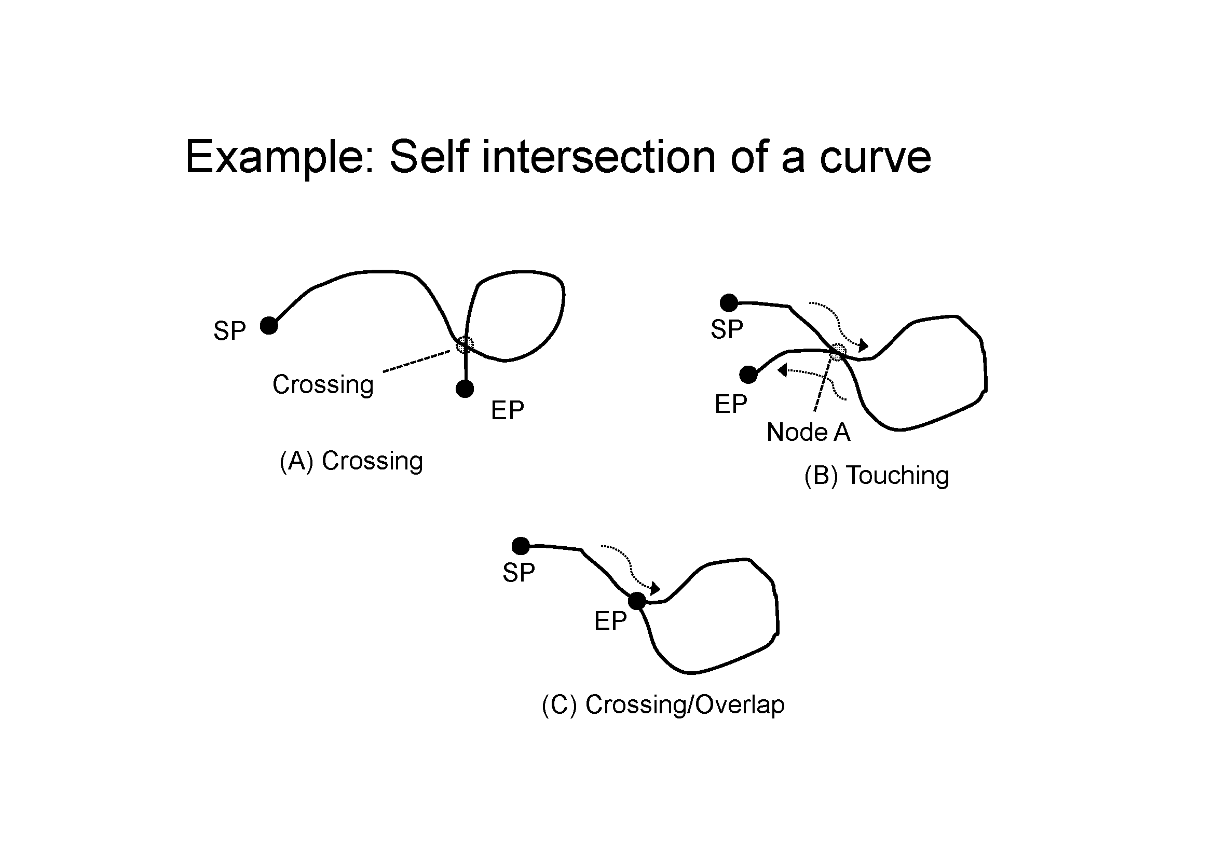

***Figure 4-1 - Self Intersect Example***

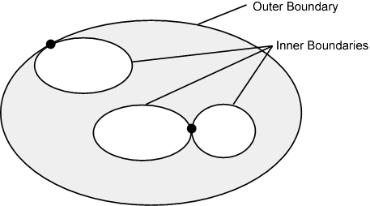

***Figure 4-2 - Area Holes***

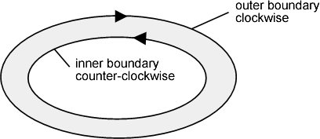

***Figure 4-3 - Boundary Direction***

Each feature type is independent and Maritime Boundaries may cross other Maritime Boundaries or zones (areas). Different features may be a **zone** represented by a geometric surface, a **limit** represented as curves or a **location** represented by a point.

The relationship of the geometric primitives used to represent a feature are described in Appendix C, clause C 2.4.

The geometry of each feature type and the feature types referenced by it shall form a consistent geometric complex.

Although S-121 data may use the full palette of S-100 Level 3a geometry there is a distinction between the geospatial locations represented in the implicit geometry of each feature and any documented positions (and line interpolations) associated with individual features required for documentation of positions in accordance with legal sources.

# Coordinate Reference System (CRS)

## Horizontal reference system

Spatial data are expressed in latitude (φ) and longitude (λ) geographic coordinates in reference to a horizontal reference system.

The longitude is stored as a negative number to represent a position west of the prime meridian (0°). Latitude is stored as a negative number to represent a position south of the equator.

Latitude and Longitude may also be stored as textual strings. This is required so that positions may be described in the exact format that they are described in the legal document (treaty or national legislation) they were extracted from. If a position is described in legal document in degrees, minutes and seconds then this description must be retained in the textual string as degrees, minutes and seconds because a conversion to decimal degrees would imply a transformation that would change the data from its legally defined value. The same latitude and longitude position may also be stored as a transformed point as a set of real numbers within a GIS system so that it can be used. That is, the values used in legal documents must be preserved, but points and other geometric primitives may have multiple representations.

Different reference systems are used by various nations. Since data may come from different legal sources such as different treaties, multiple coordinate reference systems may be used in the same dataset. Because the coastline and baseline are linked to the land, the reference systems used to define national sets of MLBs tend to be the land based reference systems that are associated with various continents and other land masses. International data may be referenced to a world reference system such as WGS84, but in such cases the transformations parameters to local land based reference systems may also be required.

MLB data is geographic data and therefore is not projected.

## Vertical coordinate reference system

Vertical position is expressed in meters above or below a vertical reference.

The IHO S-100 object catalogue includes vertical datums as registered attributes, although IHO also indicates that S-100 is not an exhaustive or authoritative definition.

## Temporal reference system

Time is measured by reference to Calendar dates and Clock time in accordance with ISO 19108:2002 Temporal Schema clause 5.4.4.

## Coordinate reference system registry

The International Association of Oil and Gas Producers (formally the EPSG) has established a register of Coordinate Reference Systems that has been recognized by the International Organization for Standardization (ISO) Technical Committee TC211. This register is not the authoritative definition of the CRS but it establishes a code that may be used to identify a CRS. The registry containing the register is available at <http://www.epsg-registry.org/>.

The IHO S-100 object catalogue also included horizontal datums as registered attributes, although IHO also indicates that S-100 is not an exhaustive or authoritative list.

# Data Quality

## Introduction

Data quality allows users and user systems to assess fitness for use of the provided data. Data quality measures and the associated evaluation are reported as metadata of a data product. This metadata improves interoperability with other data products and provides usage by user groups that the data product was not originally intended for. The secondary users can make assessments of the data product usefulness in their application based on the reported data quality measures.

For S-121 the following data quality elements have been included;

* Conformance to this Product Specification;
* Intended purpose of the data product;
* Completeness of the data product in terms of coverage;
* Logical Consistency;
* Depth Uncertainty and Accuracy;
* Positional Uncertainty and Accuracy;
* Thematic Accuracy;
* Temporal Quality;
* Aggregation measures;
* Validation checks or conformance checks including:
* General tests for dataset integrity;
* Specific tests for compliance against the S-121 data model.

## Completeness

An S-121 product contains a quality geometric and attributive description (current, accurate, consistent), homogeneous and standardised of the entire set of MLB managed by the organization which issued the data set.

### Redundant or oversampled data

MLB data is legal data and therefore redundant and oversampled data elements are not permitted. It is up to the data producer to ensure consistency with legal source documentation and correct attribution as such in the S-121 dataset.

Duplicate instances of features (defined by equal geometric realization, feature and attribute definition and temporal validity) are not permitted. Multiple instances of feature classes must be differentiated by means of attributes or metadata. Different versions of a feature instance are permitted using the versioning attributes to distinguish which is valid and any particular time.

### Omission

The description of jurisdictional zones through the definition of MLBs is often done through conceptual descriptions which may be complete or incomplete. For the sake of clarity features defined in the Feature Catalogue have very strict geometric primitives to ensure their geometries match the feature’s definition in related legislation.

In order to also support conceptual description, these features also may be described textually or by reference to other features. Certain features such as geodetic lines or loxodromes, may have densification requirements (which may be separately documented).

## Logical consistency

### Conceptual consistency

The physical implementation of the S-121 Product Specification aligns with the conceptual model according to the conformance classes defined in Appendix A. The conceptual model remains the same for all conformance classes except that different features and attributes may be included in the data set for each conformance class, and the accuracy of the attributes may be reduced for different products.

### Domain consistency

Attribute values must be validated to ensure they are within the defined range. The allowed ranges are defined in the Feature Catalogue.

### Format consistency

S-121 data formats for the various conformance classes conform to the S-100 standard, or are explicitly defined in the encoding defined in Annex B of this Product Specification.

### Topological consistency

As stated in the dataset validation tests the geometric consistency of a dataset should reflect S-100 Level 3a geometry.

The data must align with the original treaties and legal documents upon which it is based. Any inconsistencies resulting from the integration of data from different sources (different treaties or other legal sources) must be identified and accommodated but the original legal data representation must not be changed.

## Positional accuracy

### Absolute external positional accuracy

Legally authoritative data has by definition absolute accuracy because it represents a legally defined position without legal qualification. Legally authoritative data may be described in treaties, national legislation and/or deposits in compliance with UNCLOS. These absolute accuracy positions may be included in a data set along with derived data.

Official data has by definition absolute accuracy because it depicts a determination of a state’s maritime limits and boundaries where no legal process exists to make it authoritative or where a technical process has been required to realize the data; although errors may exist in the data no disadvantage will apply to a user that acts in good faith. Official data may be described in treaties, national legislation and/or deposits in compliance with UNCLOS and become legally authoritative data. These absolute accuracy positions may be included in a data set along with derived data. Official data may be normalized to a single spatial reference system.

Cartographic only data - Data derived from legally authoritative or official data has the accuracy of the transformation or other process used to generate the data. Cartographic data may be used to inform decision makers but are inadequate where legal certainty is required. A location may be represented by a point that has an absolute (legal) accuracy in one Coordinate Reference System, but has a different transformed value in another CRS. Since multiple treaties may have been agreed at different times there may be multiple locations with absolute accuracy in a MLB data set that use different CRS. If all of these points are transformed to a common CRS, so that they can be managed in a GIS and used, then each point may have an error resultant from the transformation process. The transformation source and the resultant error may be referenced in a source reference within the structure for each transformed point.

The accuracy of derived lines, such as transformed or densified lines shall also carry an accuracy statement in a referenced source for the transformation process.

## Temporal accuracy

Constituent of data features may be established at different dates. A validity attribute is mandatory for all features. A single creation date may be assigned to a component feature derived from different sources. The source description shall be used to describe the difference between the actual establishment (collection or legal) date of a feature and any date assigned to a group.

## Thematic accuracy

### Thematic classification correctness

Each of the standardized features will have an IHO code to serve as a linkage to proper depiction based on the IHO S-100 Feature Concept Dictionary. When a feature type will be realised into a specific instance the corresponding IHO code shall be linked to the object to ensure that the proper thematic classification is used. Through such automation, no further verification is needed.

### Non-quantitative attribute accuracy

The method used for evaluating the accuracy of the non-quantitative attribute values with respect to reality is determined by the type of data and its method of acquisition, and thus rely on the metadata information and data description provided at the time of the dataset integration.

### Quantitative attribute accuracy

The method used for evaluating the accuracy of the quantitative attribute values with respect to reality is determined by the type of data and its method of acquisition, and may be calculated in accordance with clause 5.3 or may rely on the metadata information.

## Dataset Validation checks

A comprehensive set of dataset validation checks will be included as Annex C to this Product Specification. These form a minimum set of data validation tests and do not provide assurance that features meet an intended level of logical, legal or topological consistency. Validation against sources, real world conditions and legal structures (including UNCLOS itself) are the responsibility of the issuing data producer. This section of the Product Specification contains guidance to ensure a minimum level of consistency is achieved across all S-121 datasets.

# Data Capture and Classification

Maritime Limits and Boundaries data is primarily acquired form multiple external and internal sources. Critical points may be defined in treaties and other agreements. The S-121 source feature is designed to support references to legal sources.

The S-121 Data Classification and Encoding Guide (DCEG) describes how data defining maritime limits and boundaries should be captured using the types defined in the S-121 Feature Catalogue. This Guide is located at Annex A.

# Maintenance

## Maintenance and Update Frequency

Maintenance of S-121 compliant datasets is done by the dataset producer issuing the dataset based on input received from either internal or external data sources. The frequency of maintenance updates of the dataset is driven by the availability of new or better data.

Updates to datasets are performed via replacement, rather than incremental update.

Versioning capacities are established for all features within the model, both information and feature types.

## Data Source

Data sources are multiple and diverse. Each nation that implements S-121 will be responsible for its own data sources, which can be described and put in relation with the associated features using the source information types.

## Production Process

One important production aspect of the S-121 Product Specification is that it shall serve through an exchange format only datasets that are in compliance with S-100 with properly defined metadata.

# Portrayal

No specific portrayal implementation is included within this Product Specification. Future editions of this Product Specification may include portrayal based on S-100 standards or may use portrayal based on web services as appropriate. Use of features derived from S-121 datasets within other Product Specifications will be subject to portrayal specified within those domains.

Data deposited with the UN Secretary General to address the deposit obligations in compliance with UNCLOS are textual, formatted to resemble legal documents that can be read without the need for special tools or software; and contain no graphical portrayal over and above that specified within this Product Specification.

# Data Product Format (encoding)

The data format for the data provided is dependent upon its use.

1. **Production**– An approved dated set of MLB data for use in production of other data products. Data is formatted in S-100 format (or in some cases in S-57 format) in a manner supported by the production GIS system or it may be formatted in GLM as a layer that may be used as an overlay or as a source to be read into a production system.
2. **Legal Declaration** – Data is provided as official legal declaration of MLB objects including supporting information that can be used to verify the correctness of the data. It is important that legal support data be simple to interpret. Since only sections of the data will be extracted and examined the efficiency of the data format is not important. The data may be verbose, but it must be easy to read by humans examining the data without the need for special tools or software.
3. **General Public Release** – An approved dated set of MLB data that may be distributed to the general public for use. Data is provided as an S-100 dataset encoded as a GML or KML file, in a GIS vendor specific file format or through an MSDI service.

See Annex B for a complete description of the data encoding for S-121.

# Data Delivery

Multiple encodings and product delivery mechanisms for the data are permitted. The Explicit Text Encoding Format (S-121 Annex B) is recommended for depositing MLB claims to the UN DOALOS, and the GML (ISO 19136) encoding is identified as a neutral encoding[2] for other requirements.

# Metadata

The S-121 Product Specification makes use of IHO S-100 and ISO 19115:2003 metadata. The Metadata in this dataset complies with S-100 Part 4a. The metadata for an entire data product dataset is defined in Table 1-1, clause 1.6 in this document. Additional metadata may be defined to be associated with any feature instance in a dataset.

Page intentionally left blank

1. Abstract Test Suite and Conformance Classes

(Normative)

* 1. Test case for attribute assignment to feature classes

1. Test purpose: Verify that all mandatory attributes associated with feature classes are provided.
2. Test method: Check that all mandatory attributes that are defined for each feature class in the Feature Catalogue are provided.
3. Reference: Appendix C, clause C 2.3
4. Test type: Basic.
   1. Test case for attribute domains
5. Test purpose: Verify that attribute domains respect Feature Catalogue definition.
6. Test method: Check that all attribute domains defined in the Feature Ccatalogue are respected.
7. Reference: Appendix C, clause C 2.3
8. Test type: Basic.
   1. Test case for UUID
9. Test purpose: Verify that a UUID attribute is defined for all feature instances.
10. Test method: Check that UUID exists for all feature instances and check that no duplication exists.
11. Reference: Clause 4.2.3
12. Test type: Basic.
    1. Test case for data completeness
13. Test purpose: Verify that all features include all the feature types required for the specific conformance class. Three conformance classes have been defined. Each described in a sub-test case in Table A-1.
14. Test method: Check that each feature required by the use case is available.
15. Reference: Clause 6.12
16. Test type: Basic.

Sub test cases establishing the conformance classes are defined in the following table.

|  |  |  |  |
| --- | --- | --- | --- |
|  | **Dataset Type** | **Conformance Class** | **List of allowed Features and Attributes.** |
| 1 | Production | Production Conformance Class | Features and Attributes with official status required for publication of charts or support of other S-100 based products. See Appendix B, clause B.2 |
| 2 | Legal Declaration | Legal Conformance Class | All available Features and Attributes required to support legal proceedings. See Appendix B, clause 2 |
| 3 | General Public Release | General Conformance Class | Limited selection of Features and Attributes allowed for release to the general public. See Appendix B, clause 2 |

***Table A- 1 – Conformance Class Elements***

* 1. Test case for feature commission

1. Test purpose: Verify that a feature is not duplicated (that is, with identical geometry, feature definition and attribution) with another feature in the same dataset.
2. Test method: Check that each feature is not duplicated with itself. Multiple feature instances from the same class shall not be duplicated. If two instances of a feature class exist they must be differentiated by means of attributes such as the versioning attribute or metadata.
3. Reference: Clause 6.2.1
4. Test type: Basic.
   1. Test case for omission
5. Test purpose: Verify that data is not missing.
6. Test method: Check that geometrically defined linear features are logically continuous using software and that geometrically defined area features are bounded by as set of boundary objects.
7. Reference: Clauses 6.2.2 and 6.3.13.1
8. Test type: Basic.
   1. Test case for domain consistency
9. Test purpose: Verify that attribute values are within specified ranges.
10. Test method: Check that attribute values are within range by means of test software.
11. Reference: Clause 6.3.2
12. Test type: Basic.
    1. Test case for format consistency
13. Test purpose: Verify that the encoding is compliant with the encoding specified by this Product Specification or allowed under S-100. Allowable formats may depend on the intended use case.
14. Test method: The format consistency test is done by the GIS software producing the data.
15. Reference: Clause 6.3.3
16. Test type: Basic.
    1. Test case for topological consistency
17. Test purpose: Verify that the dataset geometry is in line with S-100 Level 3a geometry.
18. Test method: The object topology consistency test is done by the GIS software.
19. Reference: Clause 6.3.4
20. Test type: Basic.
    1. Test case for data accuracy
21. Test purpose: Verify that objects and attributes are represented to the accuracies specified in the metadata or associated source objects associated with the data types within the data set.
22. Test method: Verify that all data elements are either of absolute accuracy (legally declared) or associated with metadata elements or source objects that describe the accuracy.
23. Reference: Clause 6.4
24. Test type: Basic.

Page intentionally left blank

1. Use Case Description

(Informative)

* 1. Overview

This Product Specification for MLBs addresses several different diverse use cases. The basic underlying model remains the same however there are some variations in the extent of the data distributed under different use cases. This is addressed in this document by the establishment of separate conformance classes in Appendix A for each use case. These conformance classes align with the use cases defined in this Appendix.

Each of the **use cases** described below address the need for different output datasets that form a subset of the information found in the administration environment. It is expected that these released datasets be associated with respective and distinct stages of testing and approval defined by the State.

The output data sets are:

1) **Production Dataset** – An approved dated set of MLB data for use in production of other data products, such as Electronic Navigational Chart, Raster Nautical Chart, or Additional Military Layers. Approved features may be included in other products. For example a Territorial Sea Outer Limit feature may be extracted from a MLB data set and included as a feature in another S-100 based data set, such as an S-101 ENC. The S-121 defined MLB data would serve as the source for the feature as used in the other S-100 based data set.

A production dataset may also consist of a set of S-121 defined MLB objects that form an overlay layer. Such a layer would be a consistent description of a set of Maritime Limits and Boundaries. The layer could be displayed on its own or as an overlay over an S-101 defined ENC or a base chart in a similar manner as is done with Additional Military Layers (AMLs).

2) **Legal Declaration Dataset** – Legal declaration of legally authoritative or official MLB feature(s) extracted directly from the administration environment at a specific date and time. Its usage may be limited depending on the implementation policies associated with the State’s governance procedures. This dataset is a human and computer readable file formatted to contain all elements to be considered a valid legal declaration. Such a dataset can be used to support a State’s activities aiming to create, manage and update an official legal declaration defining MLB features and can be used to deposit data to the UN/DOALOS in compliance with UNCLOS related obligations.

3) **General Public Release Dataset** – Approved dated set of MLBs that may be distributed to the general public for use. This dataset may include a special limiting legal usage statement in its metadata. If this data is distributed as part of a Marine Spatial Data Infrastructure (MSDI) it may be transformed to a different CRS so that it can be displayed with other data on the MSDI.

* 1. Use Cases

**Use Case #1**

|  |  |
| --- | --- |
| **Items** | **Description** |
| **Name** | Production |
| **Number** | 1 |
| **Description** | Allow access to officially released Maritime Limits and Boundary data for use in the **production** of other data products. |
| **Output** | The output of this use case is an approved and time stamped set or layer of Maritime Limits and Boundary data for use in production of other data products. |
| **Primary Actors** | The national authority responsible for the S-121 MLB data together with the organizations responsible for dependent products (such as the use of some MLB data in an S-101 ENC). |
| **Precondition** | Initial data loading, and input of external data sources. |
| **Access rights** | Read access only to the official set of MLB data for use in production of other data products. |
| **Required Products** | All. |
| **Activity and usage description** | The relevant parts of the legally authoritative and official data and their associated official metadata. |
| **Note** | In many countries production data is not allowed to represent the baselines, or the contiguous zone on the charts. |

**Use Case #2**

|  |  |
| --- | --- |
| **Items** | **Description** |
| **Name** | Legal Support Data |
| **Number** | 2 |
| **Description** | Allow the gathering of information that pertains to specific legal purposes, involving legally authoritative and official data and metadata release, linkages between release editions or computation dependencies between the different products. |
| **Output** | The output of this use case is an extract from the Administration Dataset at a specific date and time as well as all the supporting information that can be used to verify the correctness for use in legal proceedings. The data must be easy to read by legal practitioners and may consist of structured text with a possible associated illustrative map. Since the main objective of this output is human readability, where conflict exists between computational efficiency and ease of parsing and legal drafting norms, clarity for a human audience will be a priority. |
| **Primary Actors** | Legal proceedings, deposit in compliance with the depositary obligations of UNCLOS. |
| **Precondition** | Specific request needs to be made to define the criteria to be used in the data extraction from the database. |
| **Access rights** | Read access only. |
| **Required Products** | The entire official legal support data and all associated official metadata plus additional legal references, documentation and computational relationship between the data elements. |
| **Activity and usage description** | Legal consultation purposes, deposit in compliance with the depositary obligations of UNCLOS. |
| **Note** | Some material may be covered by national release policies, legal protection orders or other legal restrictions and related security needs to be maintained. |

**Use Case #3**

|  |  |
| --- | --- |
| **Items** | **Description** |
| **Name** | General Public Release |
| **Number** | 3 |
| **Description** | Allow for the distribution of data approved for releases to the general public. The data and metadata will be subject to approval by designated authority for distribution for general use only. |
| **Output** | The output of this use case is an approved dated set of MLBs that may be distributed for the **General Public Release**. Some additional data elements may also be required to complement the data to close areas and zone along the coastline or other feature elements that come from other sources than the MLBs. |
| **Primary Actors** | General Public. |
| **Precondition** | The data must be approved for open distribution. |
| **Access rights** | The general public would have no direct access rights to the entire MLBs dataset, however select data for general release may be made available through other distribution channels. |
| **Required Products** | A version of the officially released MLBs dataset that have been approved for general distribution, possibly downgraded with lower resolution. This product is not intended for production. |
| **Activity and usage description** | The general public release MLBs dataset would be distributed through separate channels than the other output products, to facilitate public access, while isolating the database from public access. For example the data may be made available through an MSDI. |
| **Note** | The General Public Release MLBs dataset may be made available as WMS layers. |

Page intentionally left blank

1. Application Schema

(Normative)

1. Overview

The S-100 Universal Hydrographic Model allows for the representation of many aspects of the marine environment. Marine resources maps, fisheries maps, a marine cadaster, political and jurisdictional maps and marine limits and boundaries use concepts of rights, ownership, and legal aspects. The theme behind some of these additional types of marine data is legal rights, restrictions and responsibilities. These types of marine data therefore need to incorporate and accurately depict rights, restrictions and responsibilities.

This Appendix describes an Application Schema model for managing legal rights, restrictions and responsibilities within the context of S-100. The high level conceptual model is based on the General Feature Model defined in ISO 19109 and the conceptual model defined in IHO S-100. The model is similar to that defined for any S-100 compliant feature based data model. The major distinguishing characteristic is the introduction of the Rights, Restrictions, Responsibilities and Parties structure derived from the ISO 19152 Land Domain Administrative Model.

The conceptual model for managing legal rights, restrictions and responsibilities is described in this Appendix to S-121. S-121 features are shown with class names beginning "S121" followed by the name of the class.

1. Feature and Attribute Structure from S-100

The S-121 Application Schema uses the same Feature and Attribute model as defined in IHO S-100. Feature types, attribute types and listed values for code lists and enumerations have their definitions recorded in the Feature Concept Dictionary Register within the IHO Geospatial Information Registry.

Attributes provide detail that establish context for a feature. S-100 defines attributes that may be associated with a feature. Types of geometry are limited by the Spatial Primitive Types defined in S-100. Thematic attributes have their definitions recorded in the Feature Concept Dictionary Register and Feature Catalogue.

The ISO 19152 Standard defines a structure to represent Rights, Restrictions and Responsibilities, Parties and Sources. This structure also acts as a set of attributes by reference. These attributes may be shared. For example, several of the features in a MLB data set may describe sovereign rights, or have common sources. The structure inherited from ISO 19152 is implemented using S-100 Information types. These Information types, their attributes and enumerations of listed values are also recorded in the Feature Concept Dictionary Register and the Feature Catalogue.

Another attribute structure inherited from ISO 19152 is the capability to version features. Versioning allows for individual features to be revised using a start and end date. An alternative approach is to version entire datasets using metadata. Both versioned features and versioned datasets can be used together.

* 1. Application Schema General Model

Figure C-1 shows the overall S-121 Application Schema model. The S-121 Feature Unit derives directly from S-100 and takes on attributes defined in the Feature Catalogue. The S-121 Spatial Attribute Type takes on the spatial attribute types of S121_Point, S121_Curve, S121_Surface or S121_Volume. These spatial attributes take their geometry from S-100 Part 7.

This Feature and Attribute structure has a relationship to S121_Source so that source information can be provided on any feature or spatial attribute. Zone (or Space) features may also have a relationship to a Basic Administrative Unit type feature, which is an Information type. This allows Rights, Restrictions and Responsibilities to be described and associated to Parties or Group Parties. These may also be sourced.

All of the Information types defining rights, restrictions and responsibilities are defined in the S-121 Feature Catalogue.

The S121_Party and S121_GroupParty are non-spatial objects. Individual parties are identified by the attribute values of the party features.

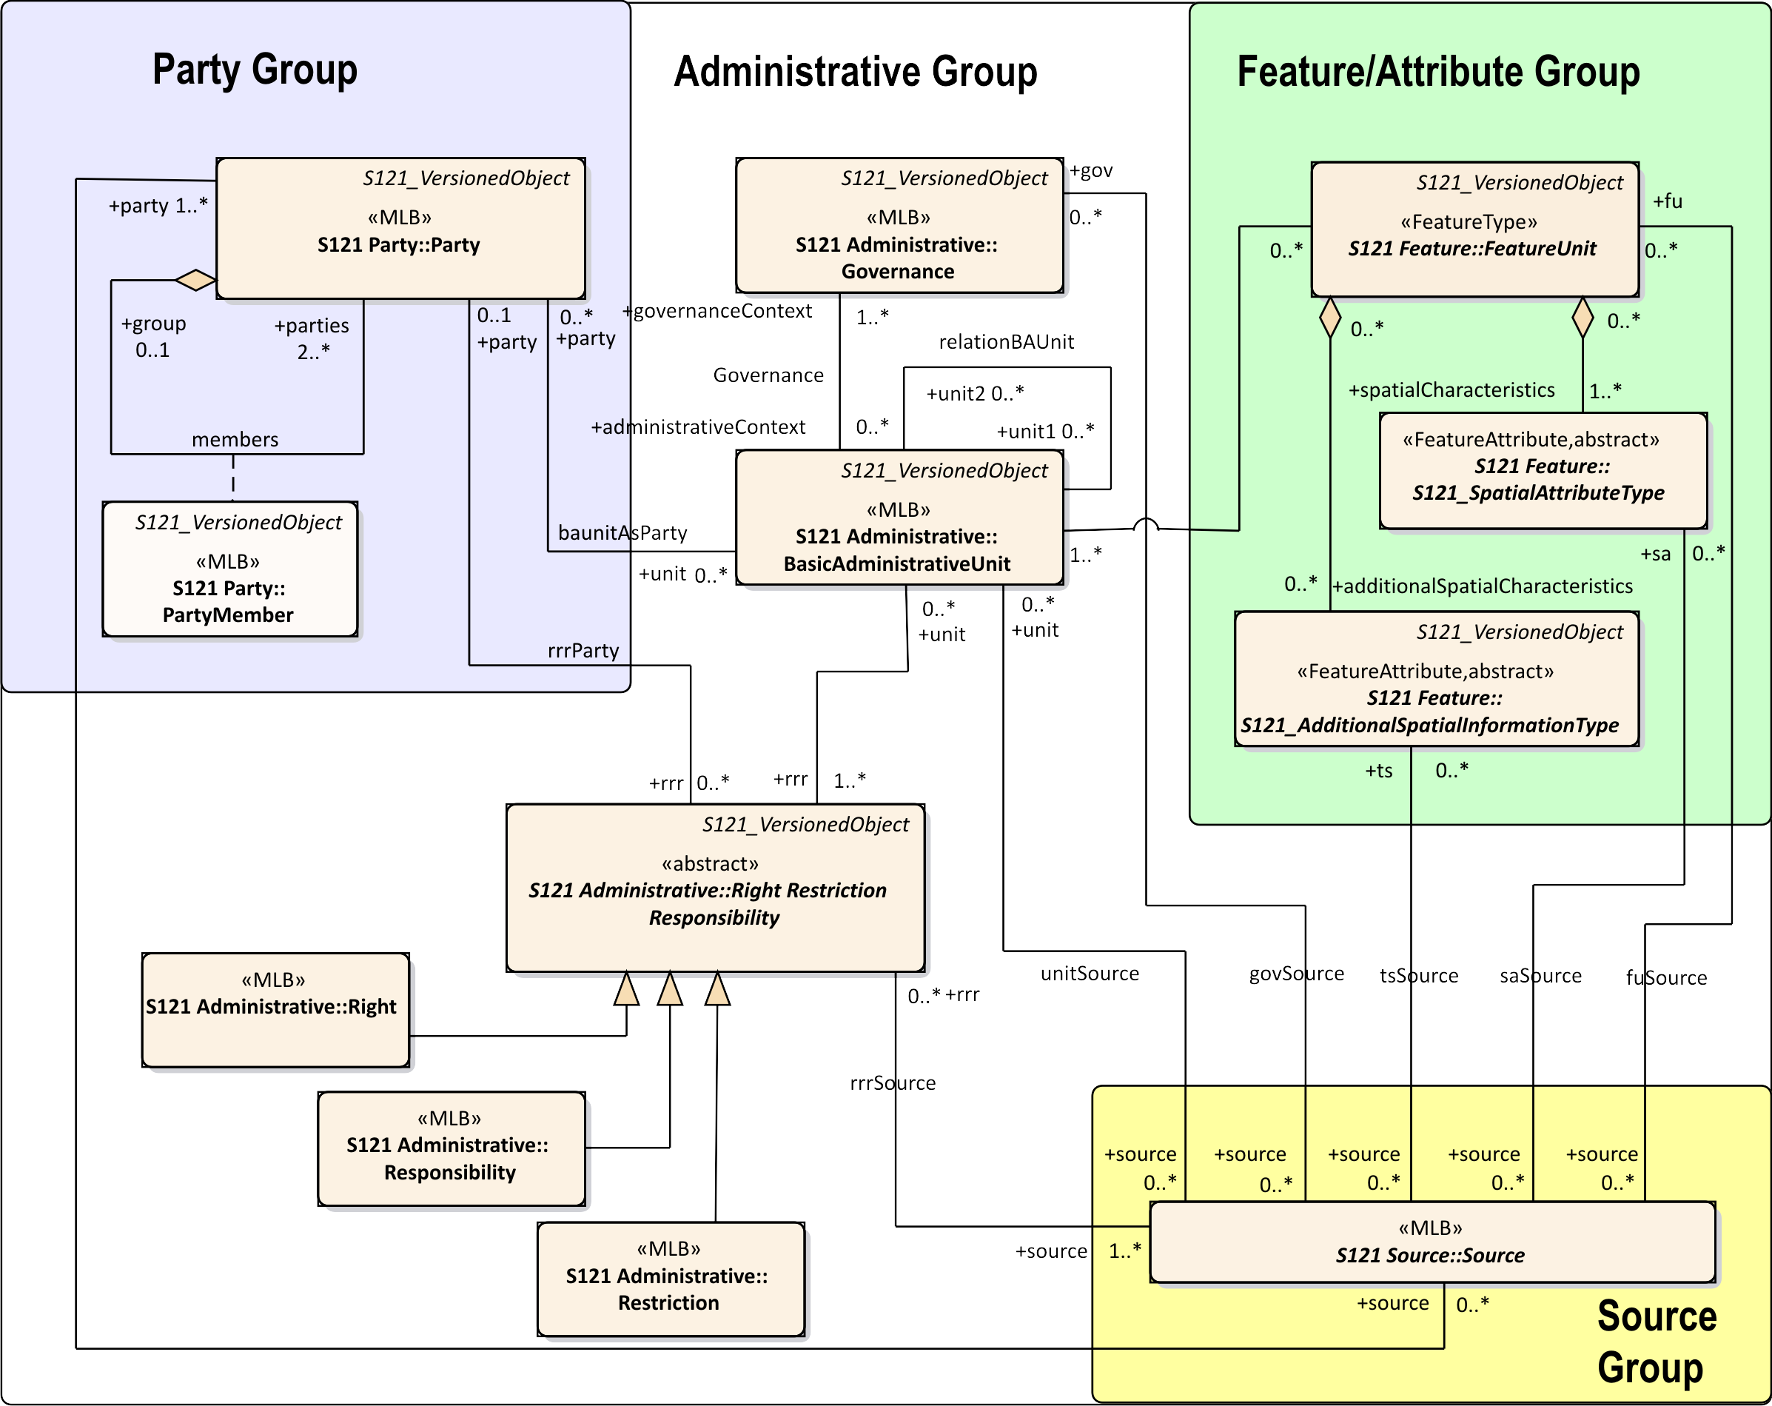

*Figure C-1 – Application Schema Model*

* 1. Basic Administrative Unit Package

The Basic Administrative Unit is an information type to “which (one or more) unique and homogeneous rights, responsibilities or restrictions are associated[3]”. This class does not take on spatial attributes itself, but is associated with a FeatureUnit, which corresponds to a feature and has its own spatial attributes. The rights, restrictions and/or responsibilities and parties structure is thus shared through the BasicAdministrativeUnit. That is, a Basic Administrative Unit is an attribute by reference for a Feature Unit. The BasicAdministrativeBAUnit feature is also a Versioned Object which allows the duration of validity for an object to be described. The BasicAdministrativeUnit is illustrated in Figure C-2.

The attribute *basicAdministrativeUnitType* is taken from the code list basicAdministrativeUnitType and describes the types of the administrative unit.

BasicAdministrativeUnit realizes attributes from the metaclass S121_GF_ThematicAttributeType. The *memberName* attribute is inherited and is renamed as *basicAdministrativeUnitName*. It establishes a name for an instance of a BasicAdministrativeUnit.

The feature component of the Application Schema model is derived from IHO S-100 allowing direct compatibility with other IHO Product Specifications. Features defined in S-121 can thus be imported into other S-100 based products.

The attribute uID is used in relationships between instances of the BasicAdministrativeUnit and Rights, Restrictions and/or Responsibilities and parties (Party) information objects.

The attribute *basicAdministrativeUnitContext* allows the context for an instance of a BasicAdministrativeUnit to be described. This would include other information that would be included with a logical administrative unit in a legal document.

Both the attribute *basicAdministrativeUnitName* and *basicAdministrativeUnitContext* support multilingual character strings in accordance with the ISO TC211 PT_Locale structure[4].

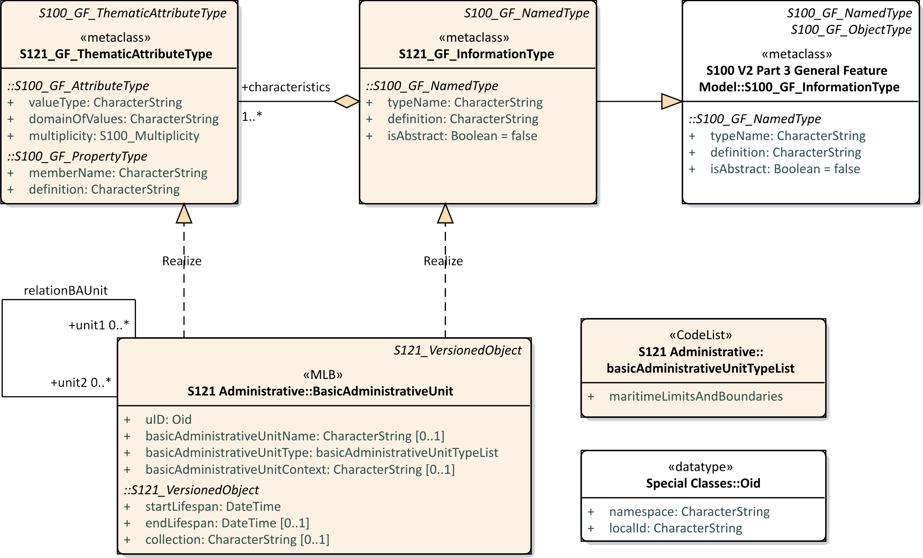

*Figure C-2 – S-121 Basic Administrative Unit*

* 1. Feature Unit

The class Feature Unit realizes S121_GF_FeatureType. The definition, code and other aspects are recorded in the Feature Concept Dictionary Register. A Feature Unit such as Exclusive Economic Zone would be associated to a BasicAdministrativeUnit information type to take on rights, responsibilities and restrictions and party administrative attributes.

The name of a feature is optionally defined in the attribute *name*. The attribute *name* is realized from the attribute *typeName* from the metaclass S121_GF_FeatureType. The *definition*, and *isAbstract* of the feature are recorded in the Feature Concept Dictionary Register so do not need to be included in attributes.

The attribute *legalStatusType* optionally is used to differentiate between the legal status of particular features. It makes use of the enumeration legalStatusCodeList.

The attribute *context* optionally describes the legal or administrative aspects of the feature object.

The attribute *context* is of type CharacterString and may support PT_Locale from ISO 19139 (or ISO 19115-3) in order to support multi-language data description.

The attribute *releasability* is optionally used to differentiate between releasability status for particular features. It makes use of the enumeration releasabilityTypeList.

Shared geometry is provided through the implementation of S-100 Level 3a geometry

All FeatureUnit Features are versioned.

Only one spatial primitive (Point, Curve or Surface) may be associated with a defined feature.

A *name* or *label* will uniquely identify the feature.

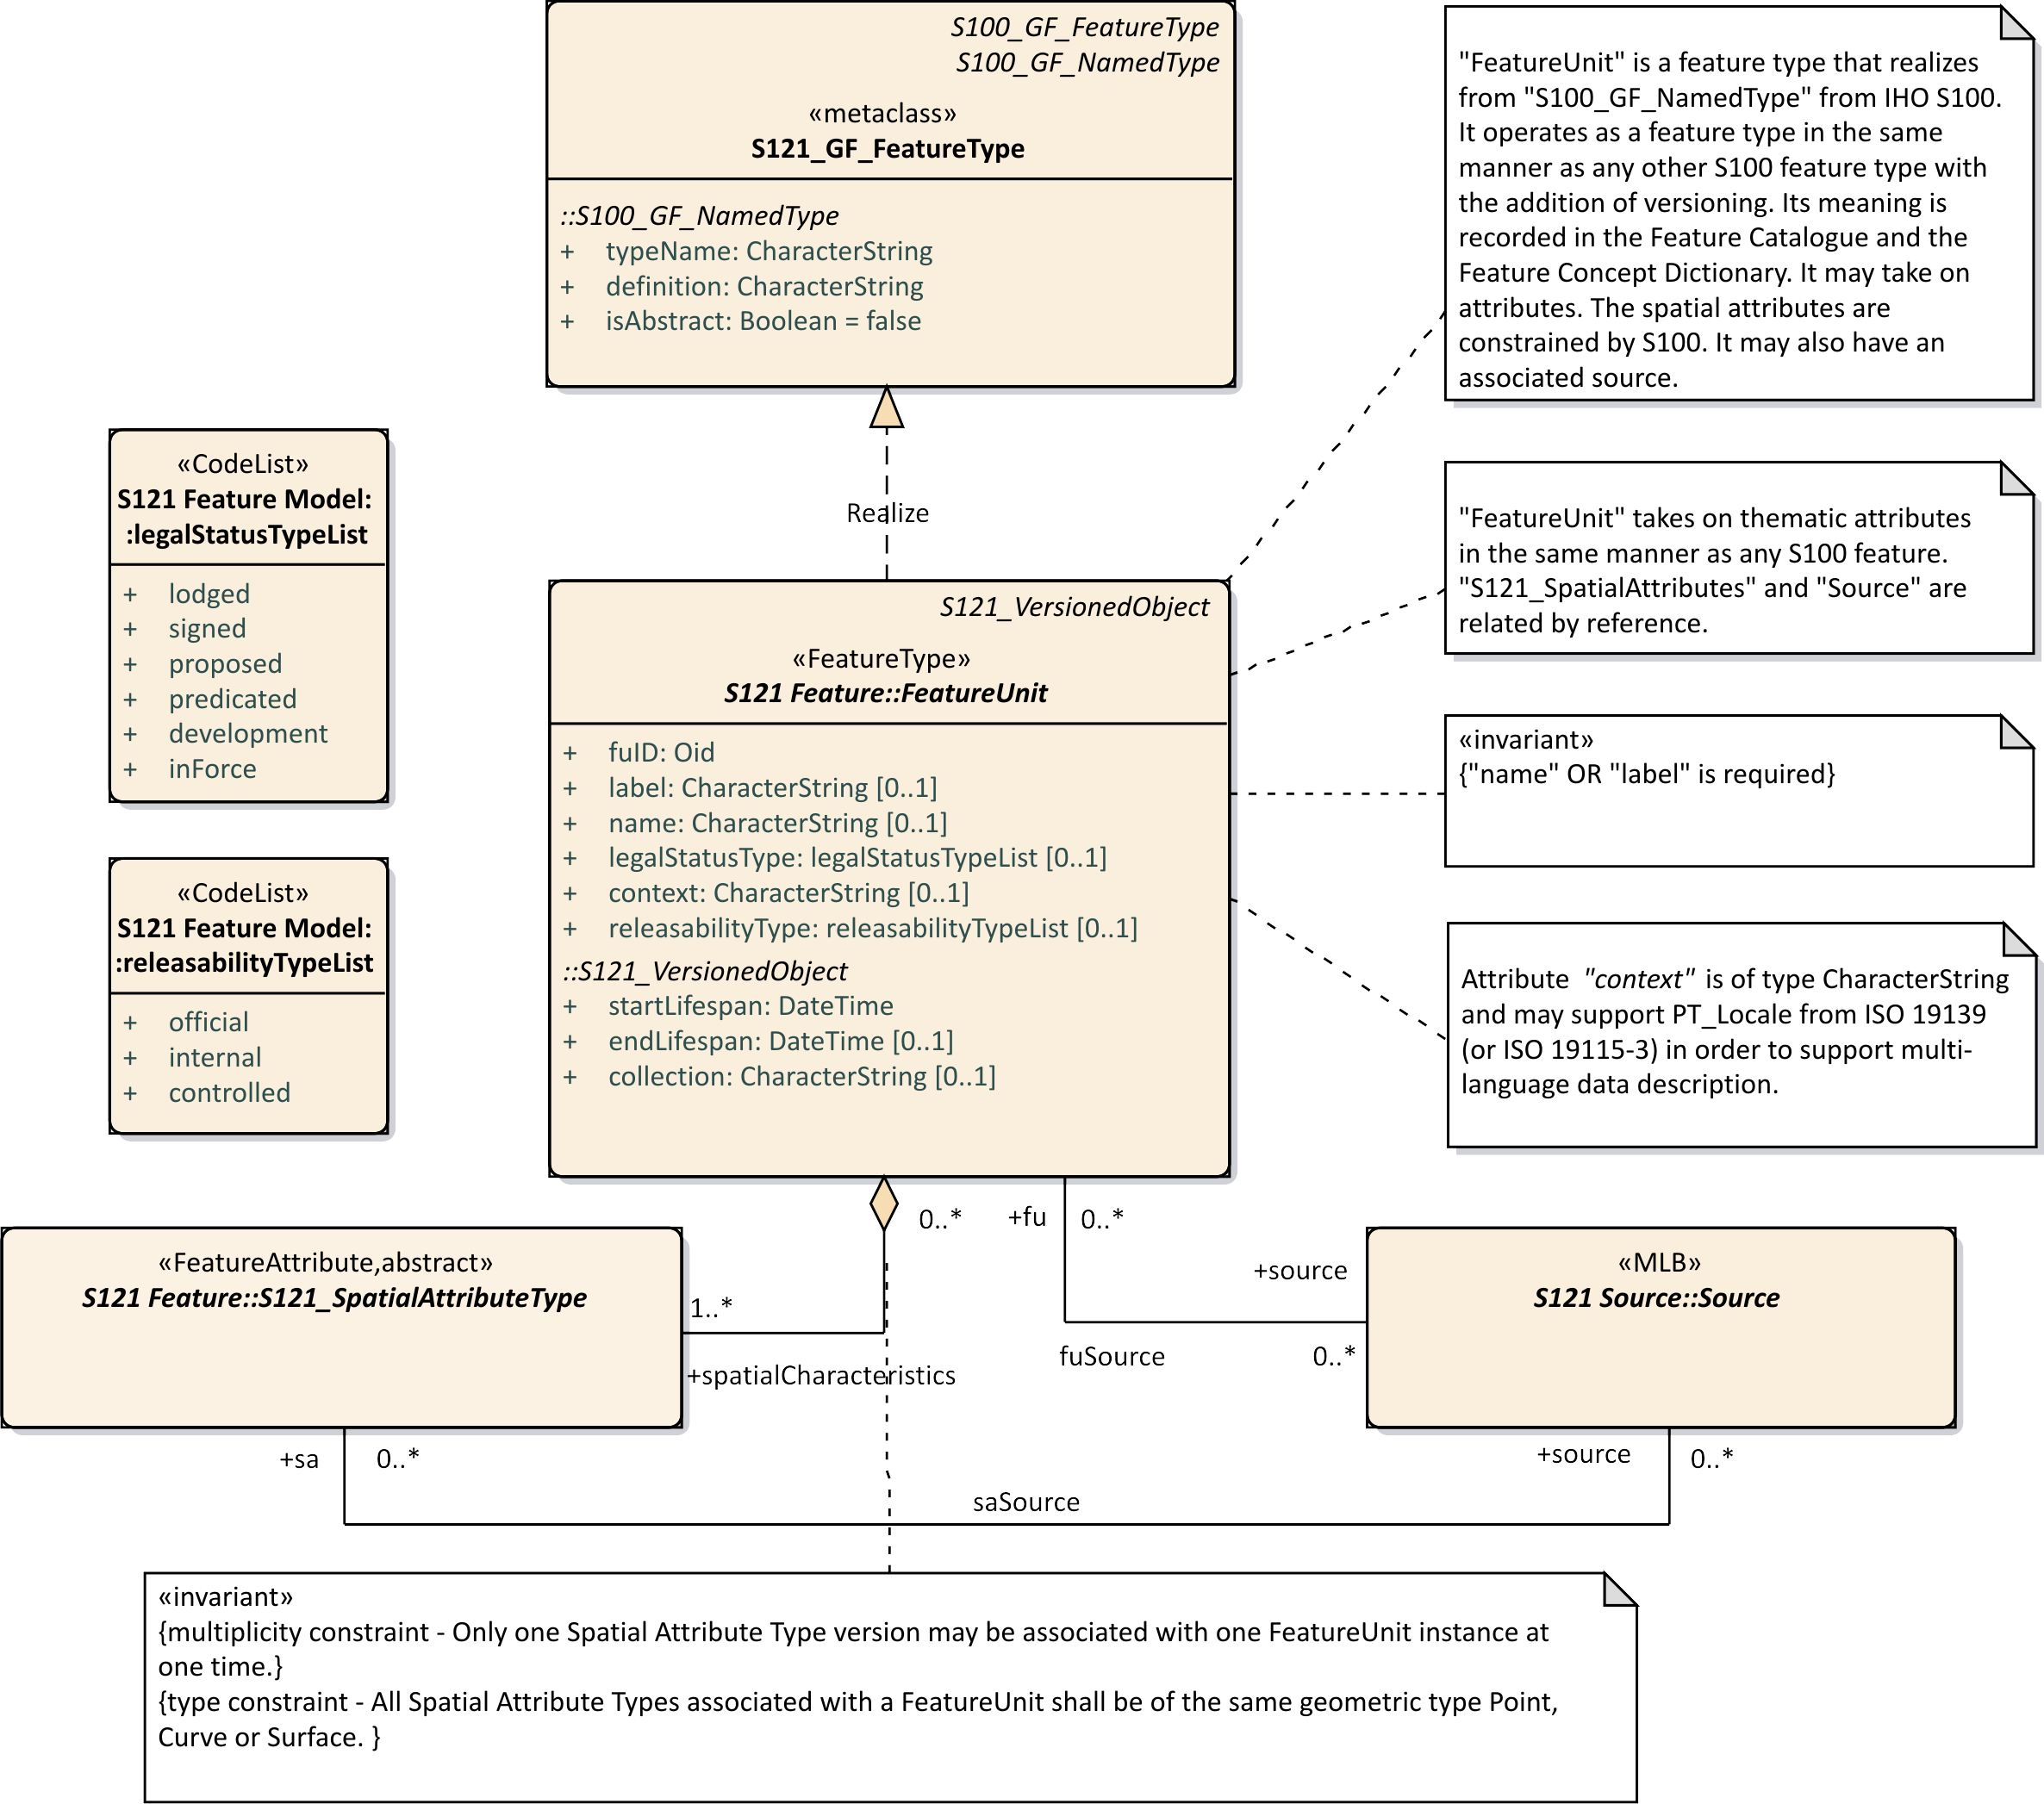

*Figure C-3 – S-121 Feature Unit*

* 1. Geometry / Additional Spatial Information

The approach to geometry in S-121 is different from that used in ISO 19152 which is based on a surveying model. S-100 allows one geometry per feature and composition is handled at the feature level through feature associations. It is straightforward to convert from ISO 19152 to the S-100 geometry model because both are based on the ISO 19107 spatial schema. They differ only in how composition is done. S-121 uses the IHO S-100 approach.

S-121 includes additional ways of describing position inherited from the ISO standard 19152. These are the description of a spatial attribute textually called “location by text” and the description of a position in a coordinate reference system different that that used to describe other positions in the same dataset. Both cases occur in real legal data. A treaty or law may describe a position as “an extension of a line from …” or by some other descriptive means. Also the reference system used in a treaty or law may be in a coordinate reference system that was used at the time the treaty or law was written. Since this textual description or position in a unique coordinate reference system are what is described in the treaty or law they are the correct legal position and must be included as is in the S-121 data. However, for an implementing production system to work, and for it to be possible to calculate and display geometries it is necessary for all the spatial primitives to be within the same coordinate reference system. A new information type carrying additional legal information has been defined, “AdditionalSpationalInformation”.

ISO19152 also allows for per object versioning. All of the feature and thematic attributes in S-121 may optionally be versioned. Versioning in the other S-100 based Data Products is done at the dataset level. If an S-121 Spatial is revised then the version of all the Features that reference that attribute as a component will need to be revised.

In S-100 spatial components may be shared. Under S-100 Level 3a geometry there may be several Feature instances that share the same spatial component by reference. For example a curve may be the spatial component referenced by a limit, a boundary or an adjacent zone. Similarly in S-121 the additional spatial information type with its attributes may be shared. A constraint is defined that locks the additional spatial information object to the corresponding S-121 Spatial Attribute object. Since the additional spatial information object and the S-121 Spatial component are locked together they must handle versioning in the same manner. Since geometry components are not versioned versioning is done at the feature level only.

The attributes and relationships of S-121_SpatialAttributeType and S-121_AdditionalSpatialInformationType are shown in Figure C-4 below. The attributes of SpatialAttributeType are the same as for any spatial attribute from S-100. The additional information type AdditionalSpatialInformation contains the additional attributes required to support the legal aspects.

The attribute *saID* is the spatial attribute identifier that is referenced by the FeatureUnit.The attribute *siID* is the additional spatial attribute object identifier that is referenced by the FeatureUnit

The attribute *locationByText* allows additional spatial information to be a textual description. This allows locations, limits, zones or spaces that are not fully described geometrically to be included. This is important in some legal cases where only some of the boundaries of a zone may be rigorously described.

A CoordinateReferencingSystem (CRS) may optionally be textually described using the attribute *referenceSystem.* Some treaties points or lines may come from different sources and it is possible in one dataset to make use of more than one CRS.

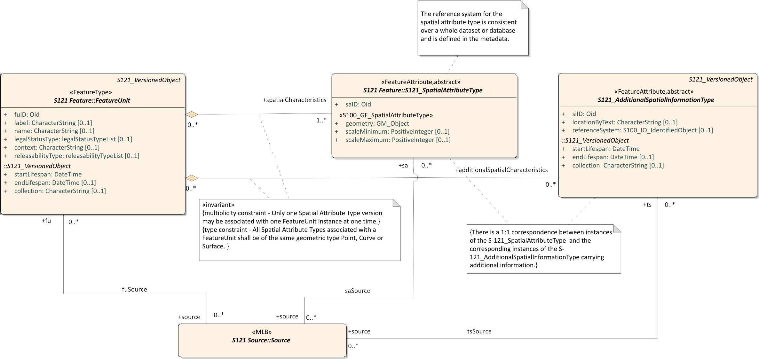

*Figure* *C-4 – S-121 Spatial Attribute Type*

The attribute *referenceSystem* references the class S100_IO_IdentifiedObject. This in turn references a series of other classes shown in Figure C-5 below that identify the CRS. This includes an optional reference to an authority that makes use of the metadata class CI_Citation. This is complex way of duplicating the role of S121_Source, so a constraint is applied to make use of the S121_Source approach.

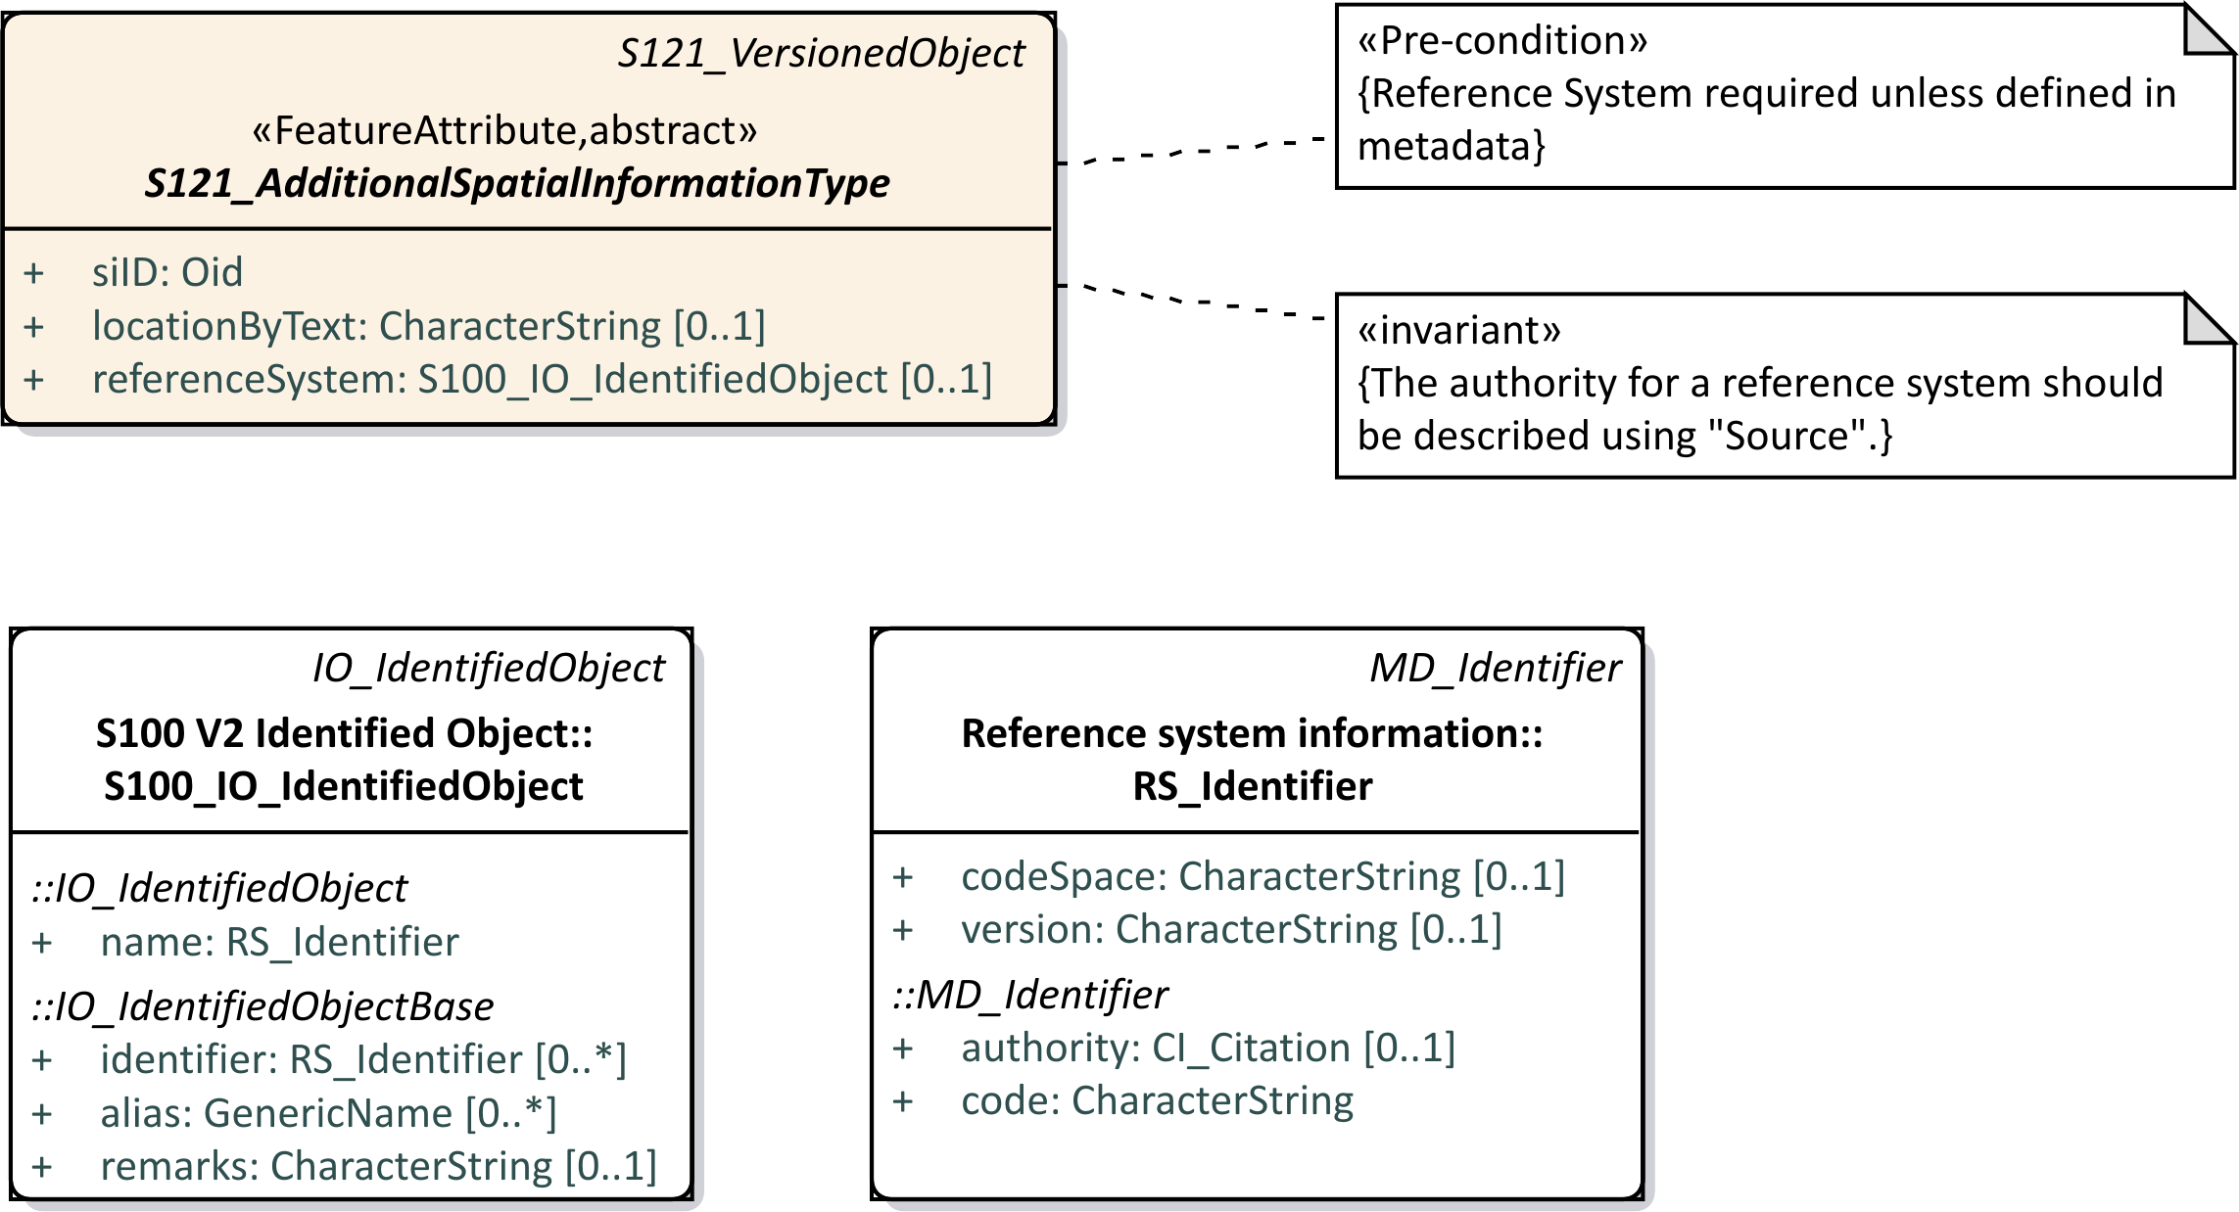

*Figure C-5 – S-121 Reference System Attribute*

Since the domain of rights for some of the UNCLOS feature instances have different vertical extents it is necessary to address the third dimension. This is done by using an optional height description attribute on 2D features to establish a volume. 3D space type features that support volume therefore have the same geometric primitives as 2D zone type features.

Figure C-6 below shows spatial geometry for each of four feature categories Location, Limit, Zone and Space.

The *locationByText* attribute is an attribute that allows a textual description. There are some situations where MLB authoritative documents do not geometrically describe all boundaries of a zone. This may be for political or legal reasons so that the dataset is not prejudicial. If both spatial geometry and text are both provided then the geometry may be considered as an approximation and the text as the authoritative description.

Feature to feature relations are allowed between the Location, Limit, Zone and Space type features. This will allow one to associate particular treaty or control points to delimit curves and particular curves to bound zones. Since administrative attributes such as Rights only apply to Zones and Spaces it is necessary to have a mechanism to relate a Zone or a Space to Limits and Location points when the geometric elements are not described.

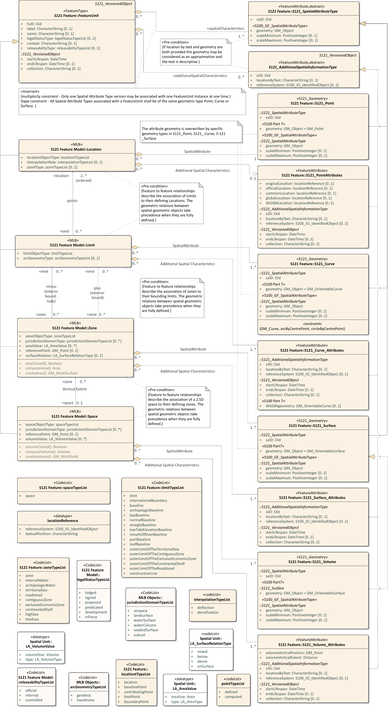

*Figure C-6 – Spatial Geometry*

The Basic Administrative Unit (BasicAdministrativeUnit) information type acts as an attribute by association to provide administrative attributes of Rights, Restrictions or Responsibilities to the Zone and Space features. This is shown in Figure C-7 below.

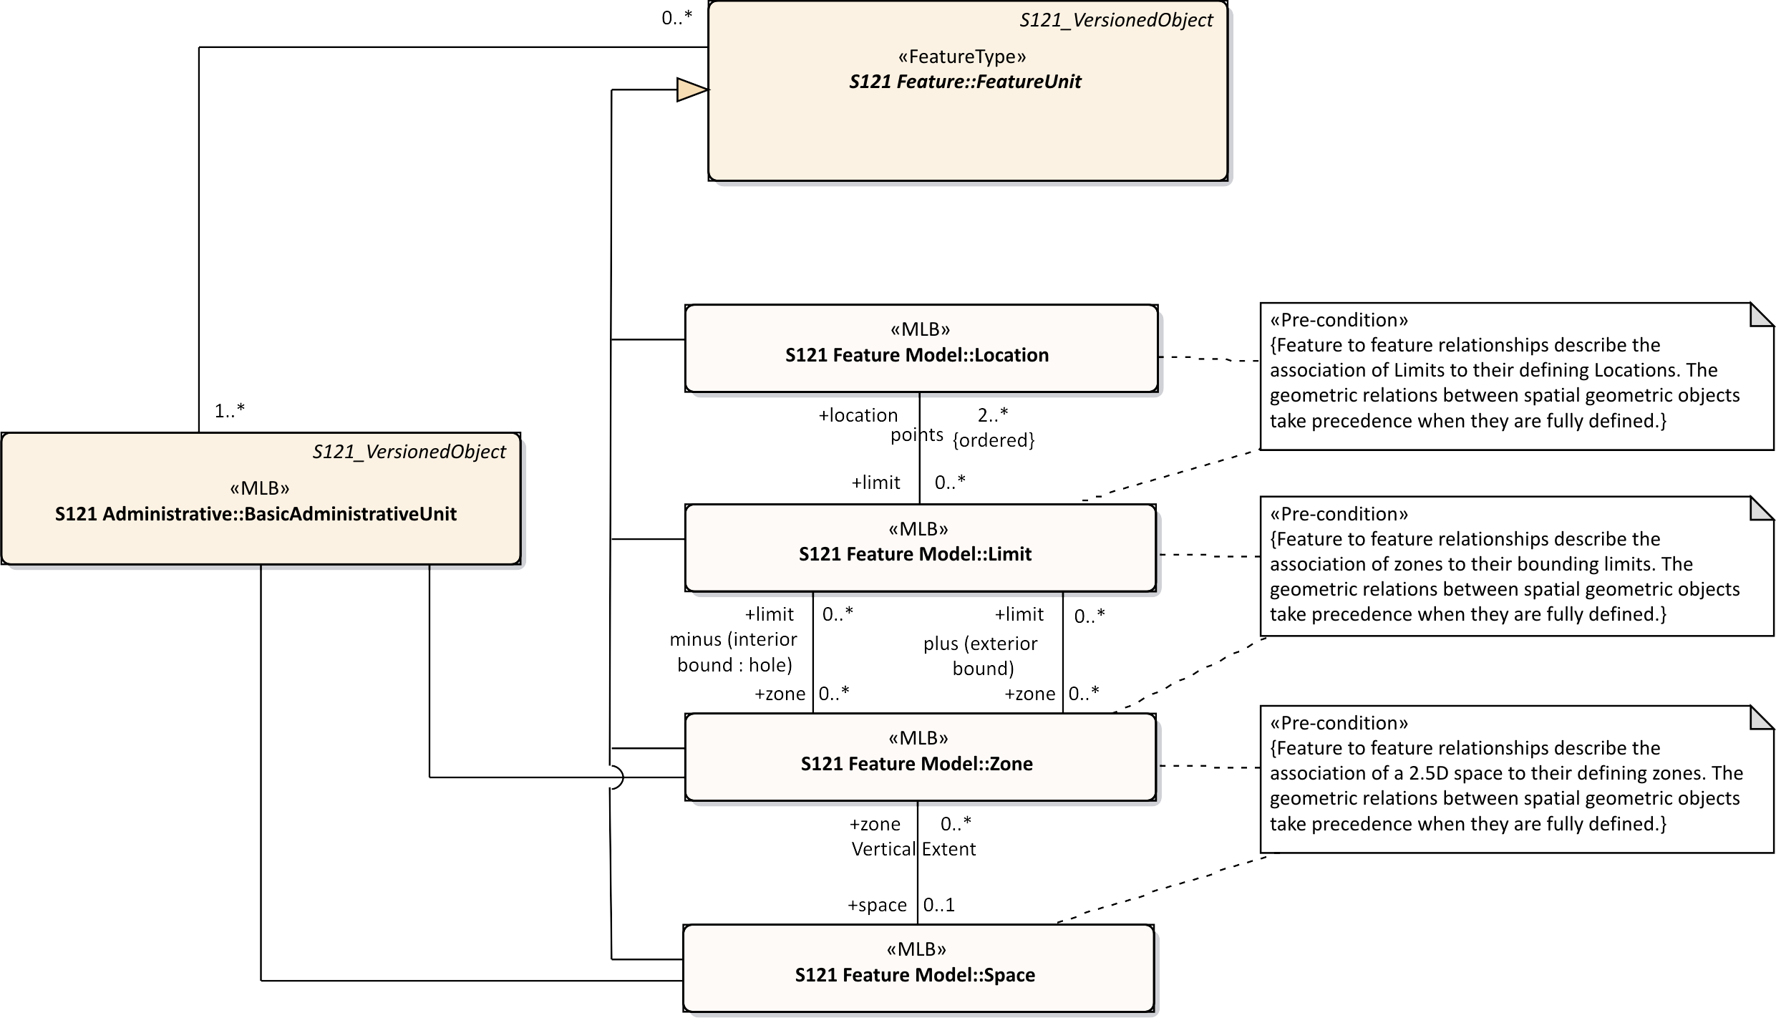

*Figure C-7 – Relation of Administrative Structure to Feature Unit*

Source is described by reference to the Source information object. In the ISO 19152 standard the two subtypes of Source are a SpatialSource and an AdministrativeSource. In S-121 this has been consolidated into one Source Information Object with two conditional attributes. The attributes *spatialSourceType* and *administrativeSourceType* that identify different enumerations. This is shown in Figure C-8 below.

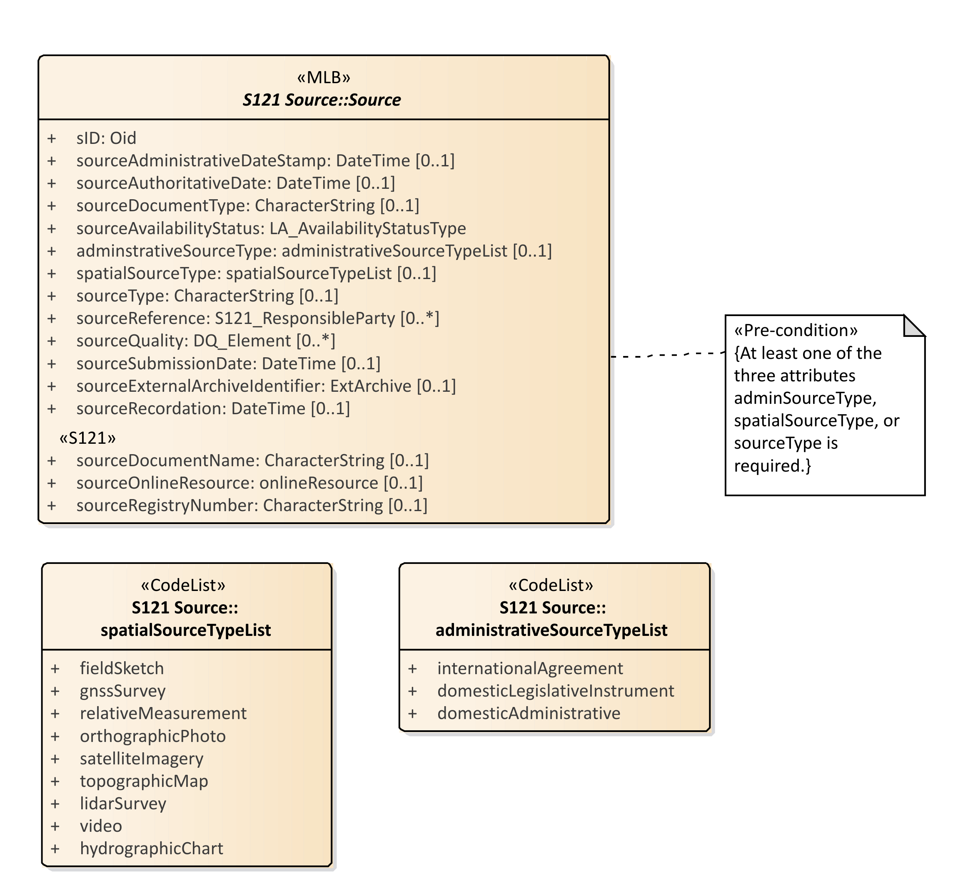

*Figure C-8 – Source*

Figure C-9 below shows the Source object with all of the associated enumerations and associated support classes. A set of attributes explicitly describe the information pertinent to source documents within a legal environment. These are:

* ***sourceDocumentName*** – Document name - for example the document (legislation, treaty, title) that defines the object;
* ***sourceOnlineResource*** – Official URL (or equivalent online resource) where the document is distributed;
* ***sourceregistryNumber*** – Unique official identifier of the record in a registry. For example, in states with registers of legislative instruments, versioning is controlled by the registry ID;

The other S121 Source attributes are:

* ***sID*** – the identifier of the source;
* ***sourceAdministrativeDateStamp*** – The moment that the event represented by the instance of S121_Source is further processed;
* ***sourceAuthoratitiveDate*** – The date of force of law of the source by an authority;
* ***sourceDocumentType*** – The type of document;
* ***sourceAvailibilityStatus*** – The status of document from the enumeration LA_AvailabilityStatusType;
* ***administrativeSourceType*** – Descriptive documentation that supports, complement or describes the associated object;
* ***spatialSourceType*** – The type of spatial "Source" document;
* ***sourceType*** – The type of "Source" document Reference;
* ***sourceReference*** – Reference to source through the class S121_ResponsibleParty;
* ***sourceQuality*** – Data Quality description through the metadata class DQ_Element;
* ***sourceSubmissionDate*** – The date of submission of the source by a party;
* ***sourceExternalArchiveIdentifier*** – The identifier of a source in an external registration;
* ***sourceRecordation*** – The date of registration (recordation) of the "Source" by registering authority.

The code lists and classes referenced are:

* ***DateTime*** – A data type for recording clock time;
* ***LA_AvabilityStatusType*** – An enumeration identifying the status of a source archive;
* ***SpatialSourceTypeList*** – Category of "spatialSourceType" (from ISO 19152:2012);
* ***AdministrativeSourceTypeList*** – Category of "administrativeSourceType" (from ISO 19152);
* ***responsibleParty*** – The responsible party of the "Source";
* ***CI_RoleCode*** – Responsible Party Role;
* ***EX_Archive*** – Metadata about an external archive;
* ***DQ_Element*** – A metadata class describing data quality of the source data;
* ***DQ_EvaluationMethodTypeCode*** – A code list of the method used to evaluate data quality;
* ***DQ_Result*** – Results of the data quality evaluation;
* ***CI_RoleCode*** – A code list of information about the function performed by the responsible party for the source data;
* ***CI_OnlineFunctionCode*** – A code list of the online function performed by an online resource as part of a contact for a responsible party for a source;

In addition the ISO metadata class CI_ResponsibleParty has been realized in S-121 to be ResponsibleParty. This includes the classes Contact, OnlineResource and Address that are realizations of the ISO classes CI_Contact, CI_Address and CI_OnlineResource. The attributes and inheritance of S121_Source are shown in Figure C-9.

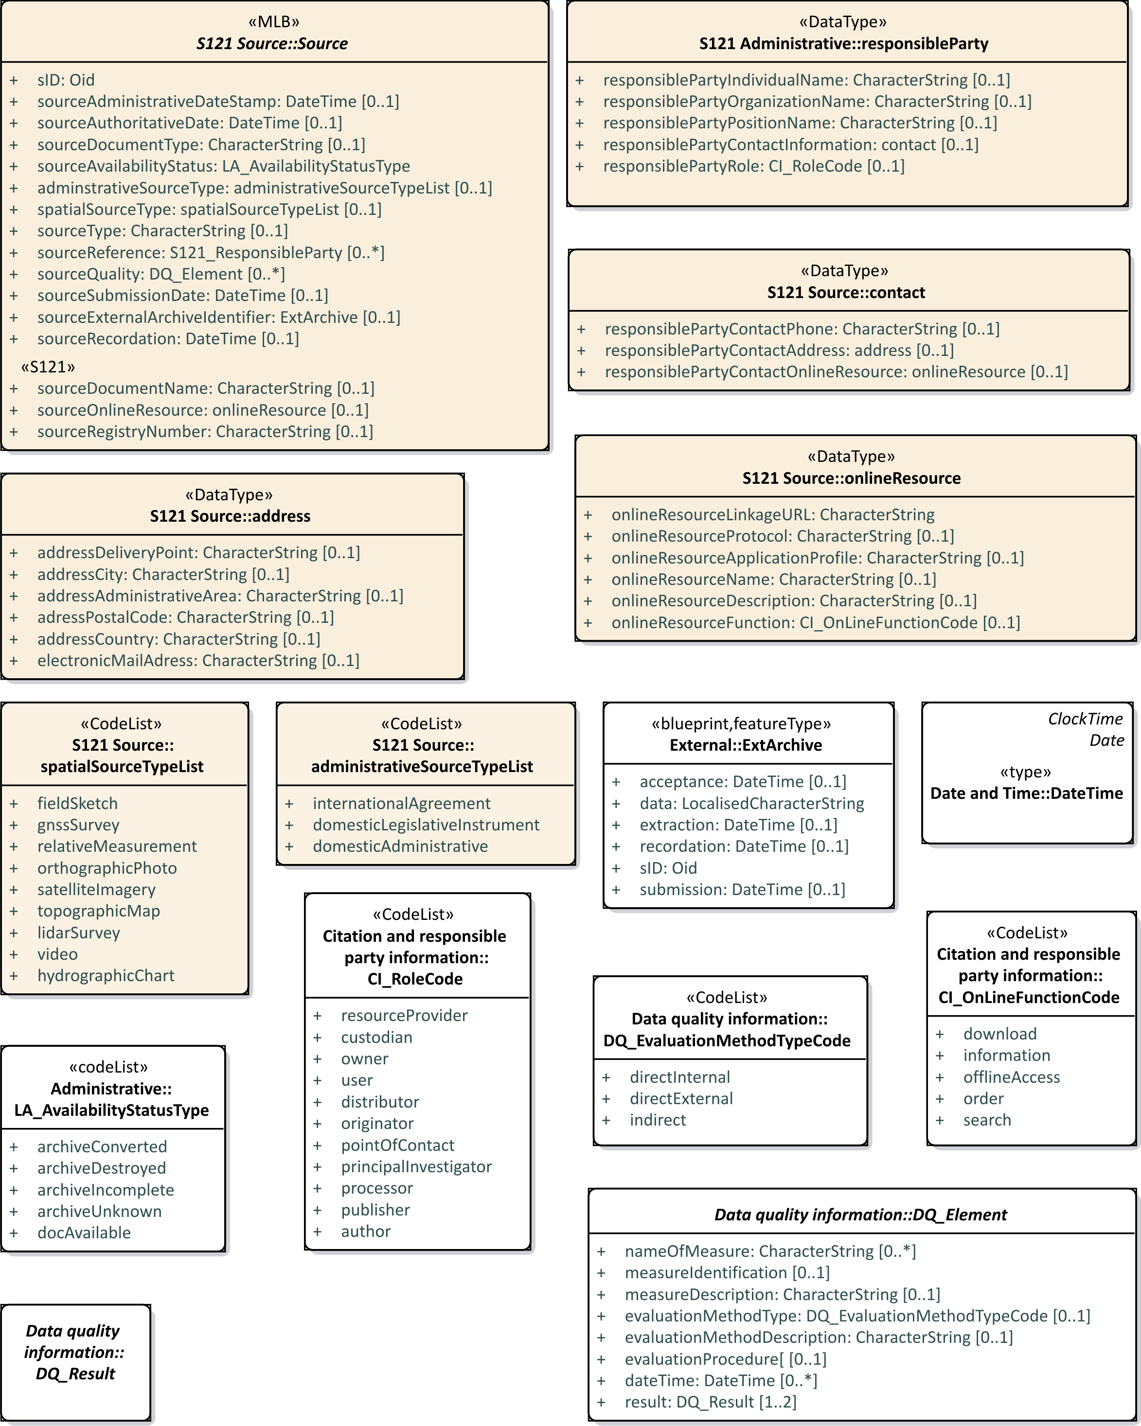

*Figure C-9 – S121_Source Attributes*

* 1. Party Unit Package

A party is “a person or organization that plays a role in rights[5]”. A Party is considered as an object which allows it to be shared. That is, a party may be part of several different rights, responsibilities and restrictions. A Group Party is also a Party that consists of several individual parties. The PartyMember class provides an attribute on the composition attribute that forms a group out of several party members. This optional attribute allows parties to have different shares within a group. The types of Parties and Group Parties are described by *partyType* and *partyGroupType*. Figure C-10 below shows the Party structure.

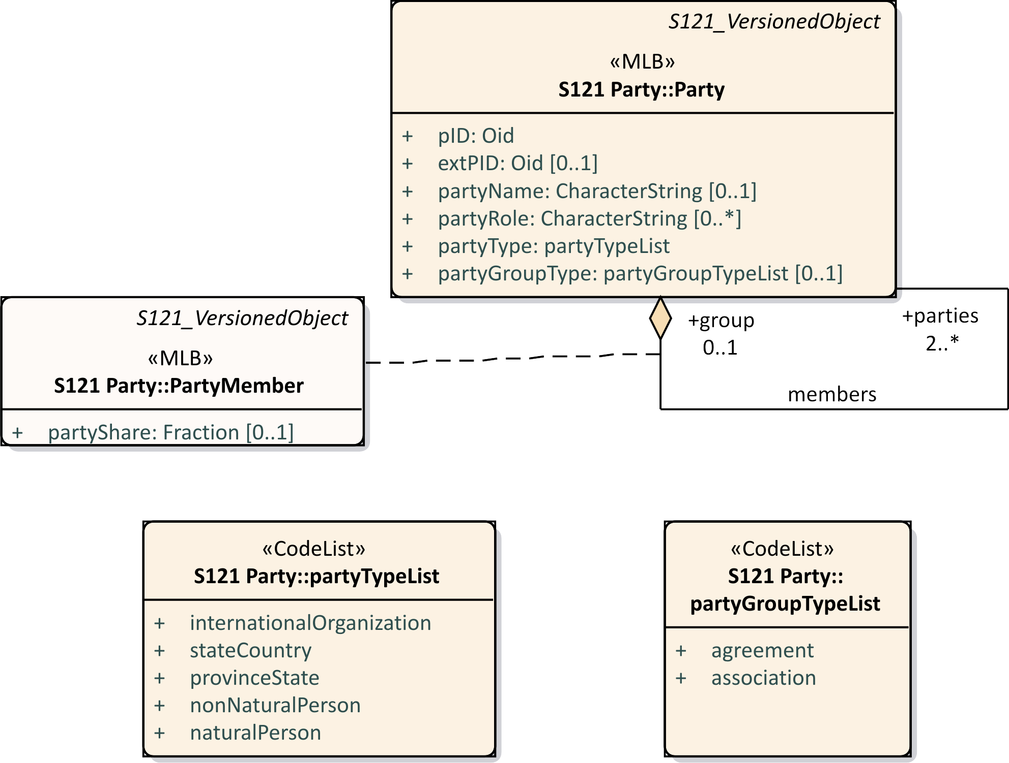

*Figure C-10 – S121_Party Package*

The relationship between Parties, Group Parties, Rights, Restrictions and Responsibilities and feature instances (BasicAdministrativeUnit) is by named associations.

The S121_Party is structured in an equivalent but simpler manner than ISO 19152.

* 1. Rights, Responsibilities and Restrictions (RRR) Administrative Package

The RRR administrative package associates parties with Basic Administrative Units (BasicAdministrativeUnit). There are three subtypes realised as information types.

1. Right, with rights as instances. Rights are primarily in the legal domain.

2. Responsibility, with responsibilities as instances.

3. Restriction, with restrictions as instances. Restrictions usually apply to features independent of the rights; that is, the related party can change and the restriction remains.

Rights, Responsibilities and Restrictions are information types associated by reference to BasicAdministrativeUnit features.

The code lists that define the rights, responsibilities and restrictions are *rightTypeList*, *responsibilityTypeList*, and *restrictionTypeList*. Enumerations are used, rather than character strings in order to ensure consistency.

These features are stand-alone entities associated by reference. They are Information types and do not carry geometry. Feature objects therefore point to an appropriate information type. For example if a particular restriction applies to a fishing zone, then all features that invoke the restriction can be associated to a single instance of the information type that establishes that restriction. If the restriction is changed it only needs to be changed once, not through the attributes in possibly hundreds of feature objects.

Figure C-11 below shows the S-121 Administrative Rights, Responsibilities and Restrictions.

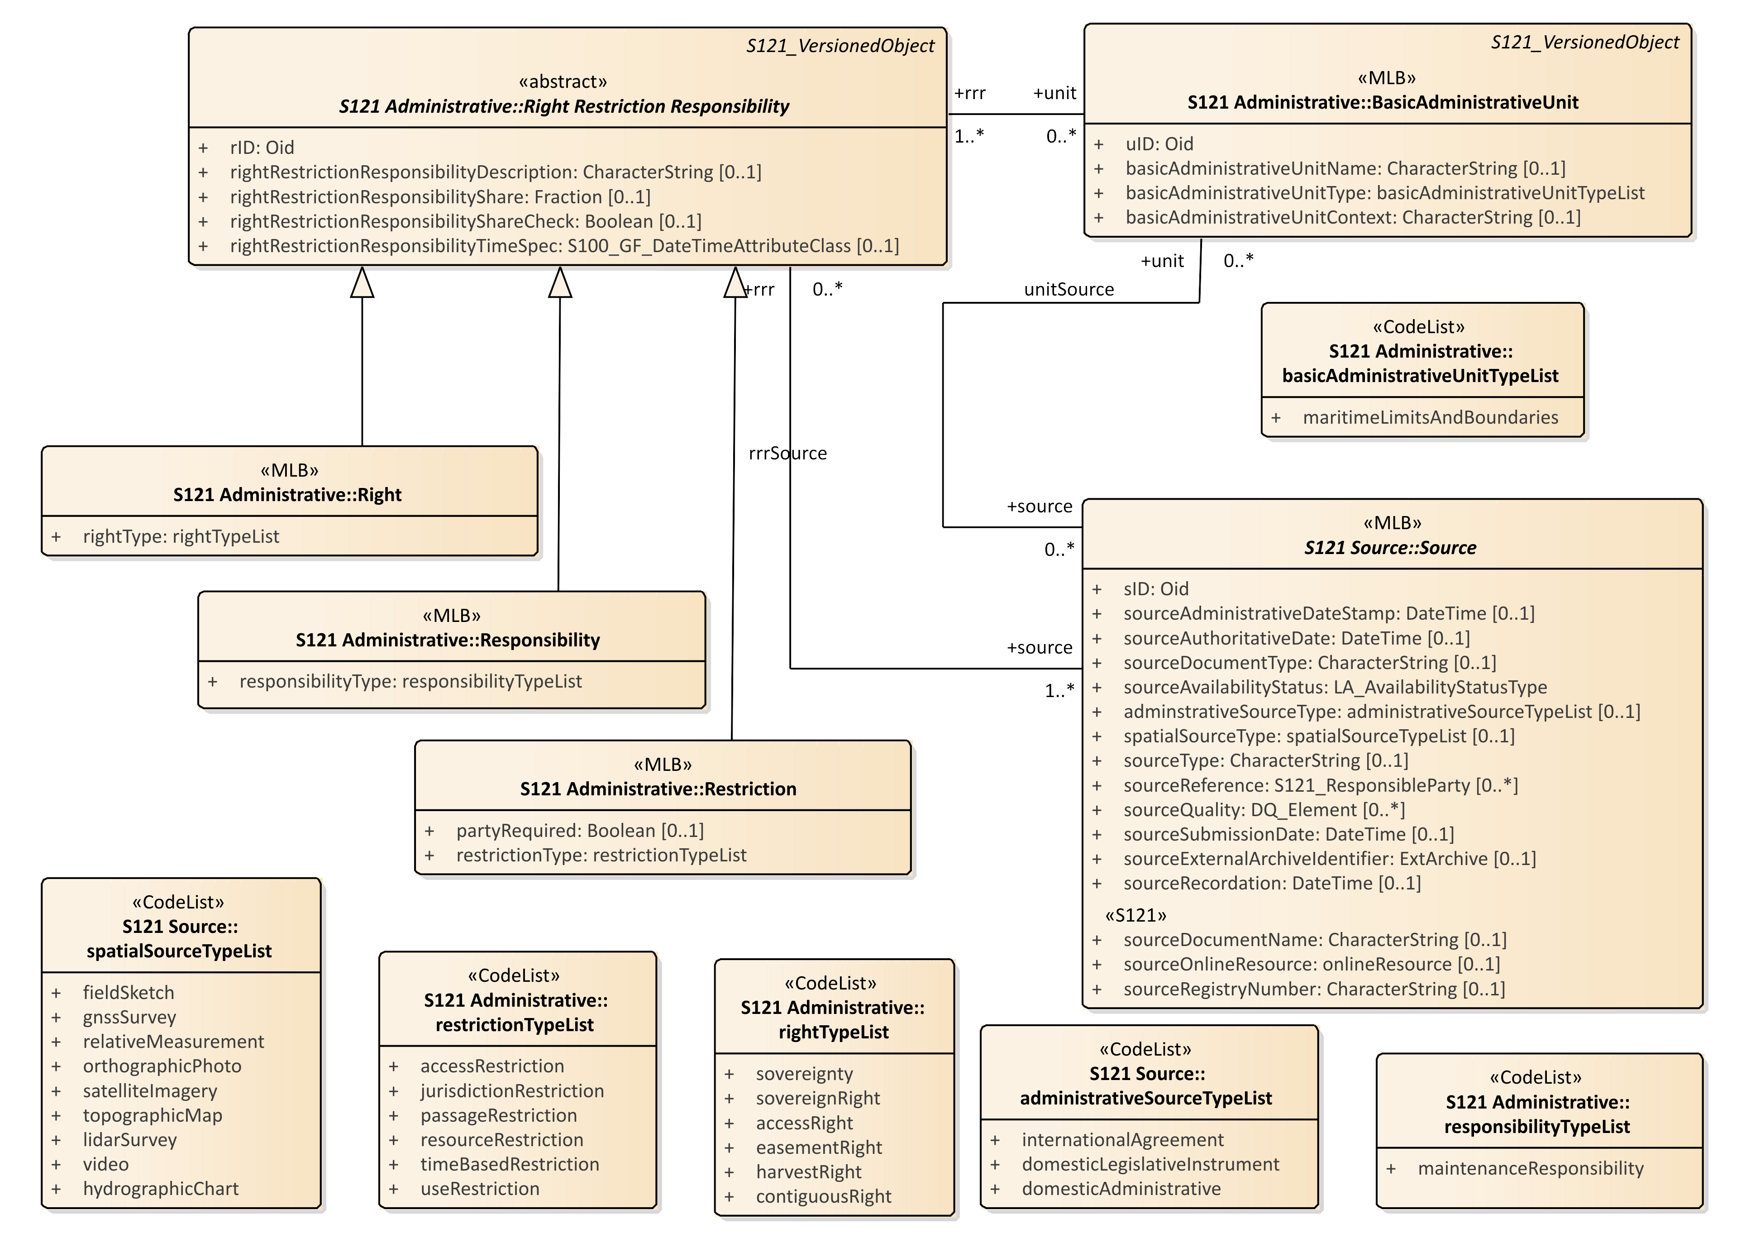

*Figure C-11 – S-121 RRR Administrative Package*

* 1. Governance Object

Treaties and other descriptive legal documents normally contain a textual preamble that contains information specific to the legal status of the data, or exchange data set (such as a deposit in compliance with the depositary obligations of UNCLOS). This information requires another type of Information Type. This information type is called a governance object. This information is not metadata, it is an integral part of the dataset containing specific legal text, but it may duplicate some metadata elements such as title. The governance data object may be versioned and can reference a source or sources.

All of the attributes of the governance object are optional except for a unique identifier attribute: *govID*. There may be zero or more (0..*) governance objects associated with a BasicAdministrativeUnit. When generating a data set from data held in the S-121 data model the governance objects associated with the Basic Administrative Units selected for output would be included with the output data.

There are several optional attributes that may be used to carry specific aspects of the textual preamble such as the title (governanceTitle), or the reference number (referenceNumber) of the data. The textual preamble would be carried as a character string in the governance description (governanceDescription) attribute.

The attributes are:

* ***govID*** – A unique character string and a namespace identifier which is also a unique character string;
* ***referenceNumber*** – The reference number of the legal reference;
* ***label*** – A short textual identifier of the governance object;
* ***name*** – The name of the governance object;
* ***governanceTitle*** – The title of the legal reference;
* ***governanceDescription*** – A character string containing the governance statement;
* ***releasibilityType*** – Optionally used to differentiate between releasability status for particular features;
* ***dateApproved*** – The date at which the legal statement or document was approved by the appropriate governing body;
* ***dateConsidered*** – The date at which the legal statement or document was considered by the appropriate governing body;
* ***dateIntroduced*** – The date at which the legal statement or document was introduced.

Figure C-12 below shows the Governance Object structure.

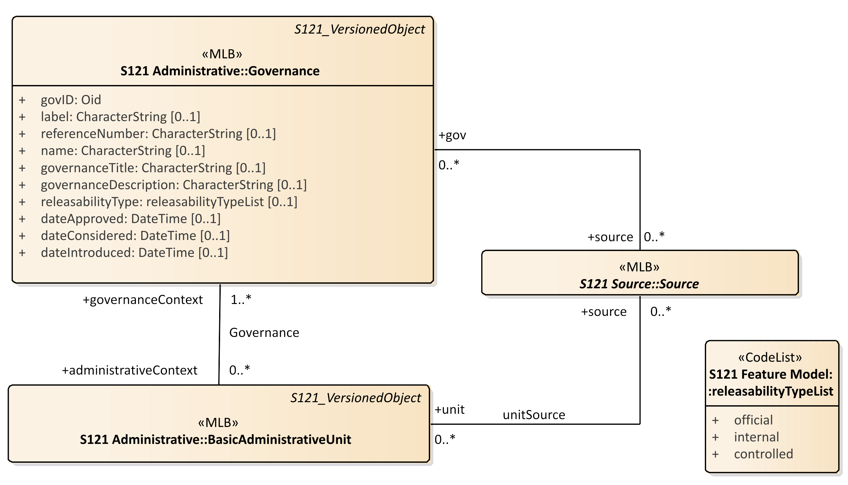

*Figure C-12 – Governance Object*

* 1. Versioned Object

Versioning is a critical aspect for legal data. Each feature and information object can be separately versioned. This is done by including two attributes in each of these features that define the beginning and end dates of validity.

Versioned and non-versioned features may be combined in a dataset. Non-versioned objects are then implicitly versioned by the metadata date stamp on the whole dataset. Versioning is particularly important when data is extracted from an online database. Figure C-13 below shows the S-121 versioning attributes for S-121 features.

The VersionedObject attributes also contains an attribute *collection*. This attribute allows one to describe several different collections of data. For example the UN may hold data from Canada, France and other countries in the same database. There may be a unique numbering or naming system for feature and information object instances in Canada and another one in France, but there is no assurance that the two namespaces do not conflict. The *collection* attribute identifies which “collection” a data element is a member of. Effectively it ensures a unique namespace. This attribute is conditional. It is required in a database that contains information from different suppliers. The attribute is not required in a country’s national database (if the country has a unique and unambiguous name or numbering system, and it is not required in an exchange data set because the metadata of the entire dataset uniquely identifies the dataset).

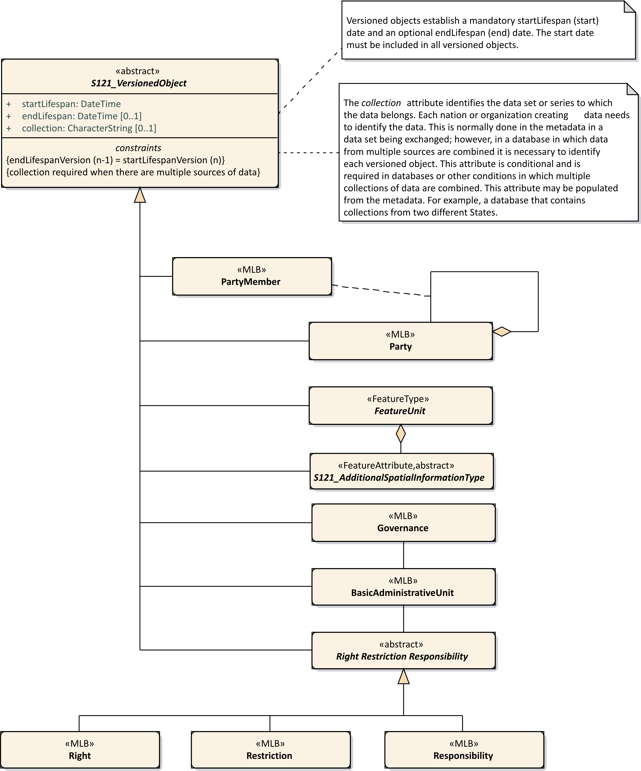

*Figure C-13 – Versioned Objects*

* 1. Implementation Model

The implementation model for the S-121 Administrative Group is shown in Figure C-14 below. It shows four groups of features, the Feature/Attribute Group which is derived directly from S-100 and the three additional groups implemented by S-121. There are only 7 instantiable classes. These additional groups are the Administrative Group that defines the Basic Administrative Unit and the Rights, Restrictions and Responsibilities. The Party group defines Parties and the Source Group defines Source references. The governance object is also part of the Administrative Group.

The structure is conceptually simple. There is a link from a Feature Unit to an Administrative Group BasicAdministrativeGroupUnit for Zone type features and Space type features. The Administrative and Party structure simply behaves as an attribute by association describing the Rights, Responsibilities and Restrictions and the Parties involved for that Feature.

The Administrative group and the spatial primitives associated with a feature may also reference the S121_Source in the Source group. This is also by reference and it allows source references to be shared.

The Feature, Administrative and Party groups are versioned objects. If a source changes a new source reference instance should be generated.

The implementation model shown in Figure C-14 has resolved many of the relations to be navigable in one direction meaning that they can be implemented as pointers in an encoding structure. The pointers emanate from the FeatureUnit making the feature the central object in alignment with the philosophy of the underlying S-100 GFM.

The integration of features from S-121 into another S-100 based product such as S-101 is then straightforward. Versioning can be resolved to a single instance in time (since S-101 and many other types of data are versioned at the dataset level), and those attributes from the S-121 administrative structure relevant to S-101 encoding structures can be converted to thematic attributes of the feature. Feature Types and spatial primitives should then be directly usable. For example, if a producer wishes to include an EEZ boundary in an electronic chart, the feature from an S-121 dataset, “Outer Limit of the Exclusive Economic Zone” with its spatial primitives could be imported directly or converted to whatever feature class name is appropriate in the S-101 context. The S-121 feature would have a pointer to an instance or instances of BasicAdministrativeUnit information types and then to Right, Responsibility and Restriction and Party information types. Selected information from these classes, such as the sovereign right and country, could be converted into an attribute on the feature used in S-101. The S-121 structure addresses the more rigorous legal environment and the digital navigation environment can take what it needs into the S-101 environment.

The structure of the party group has been transformed in the implementation model. Since the GroupParty class inherited from ISO 19152 is a subtype of the Party class with an extra attribute, these two classes have been combined with the inclusion of a constraint that indicates that the additional attribute party group type (partyGroupType) is to only be used in a group party. The Party Member class then becomes a related feature. This simplifies the implementation for those systems that cannot support a relationship class used for the purpose of carrying an association attribute.

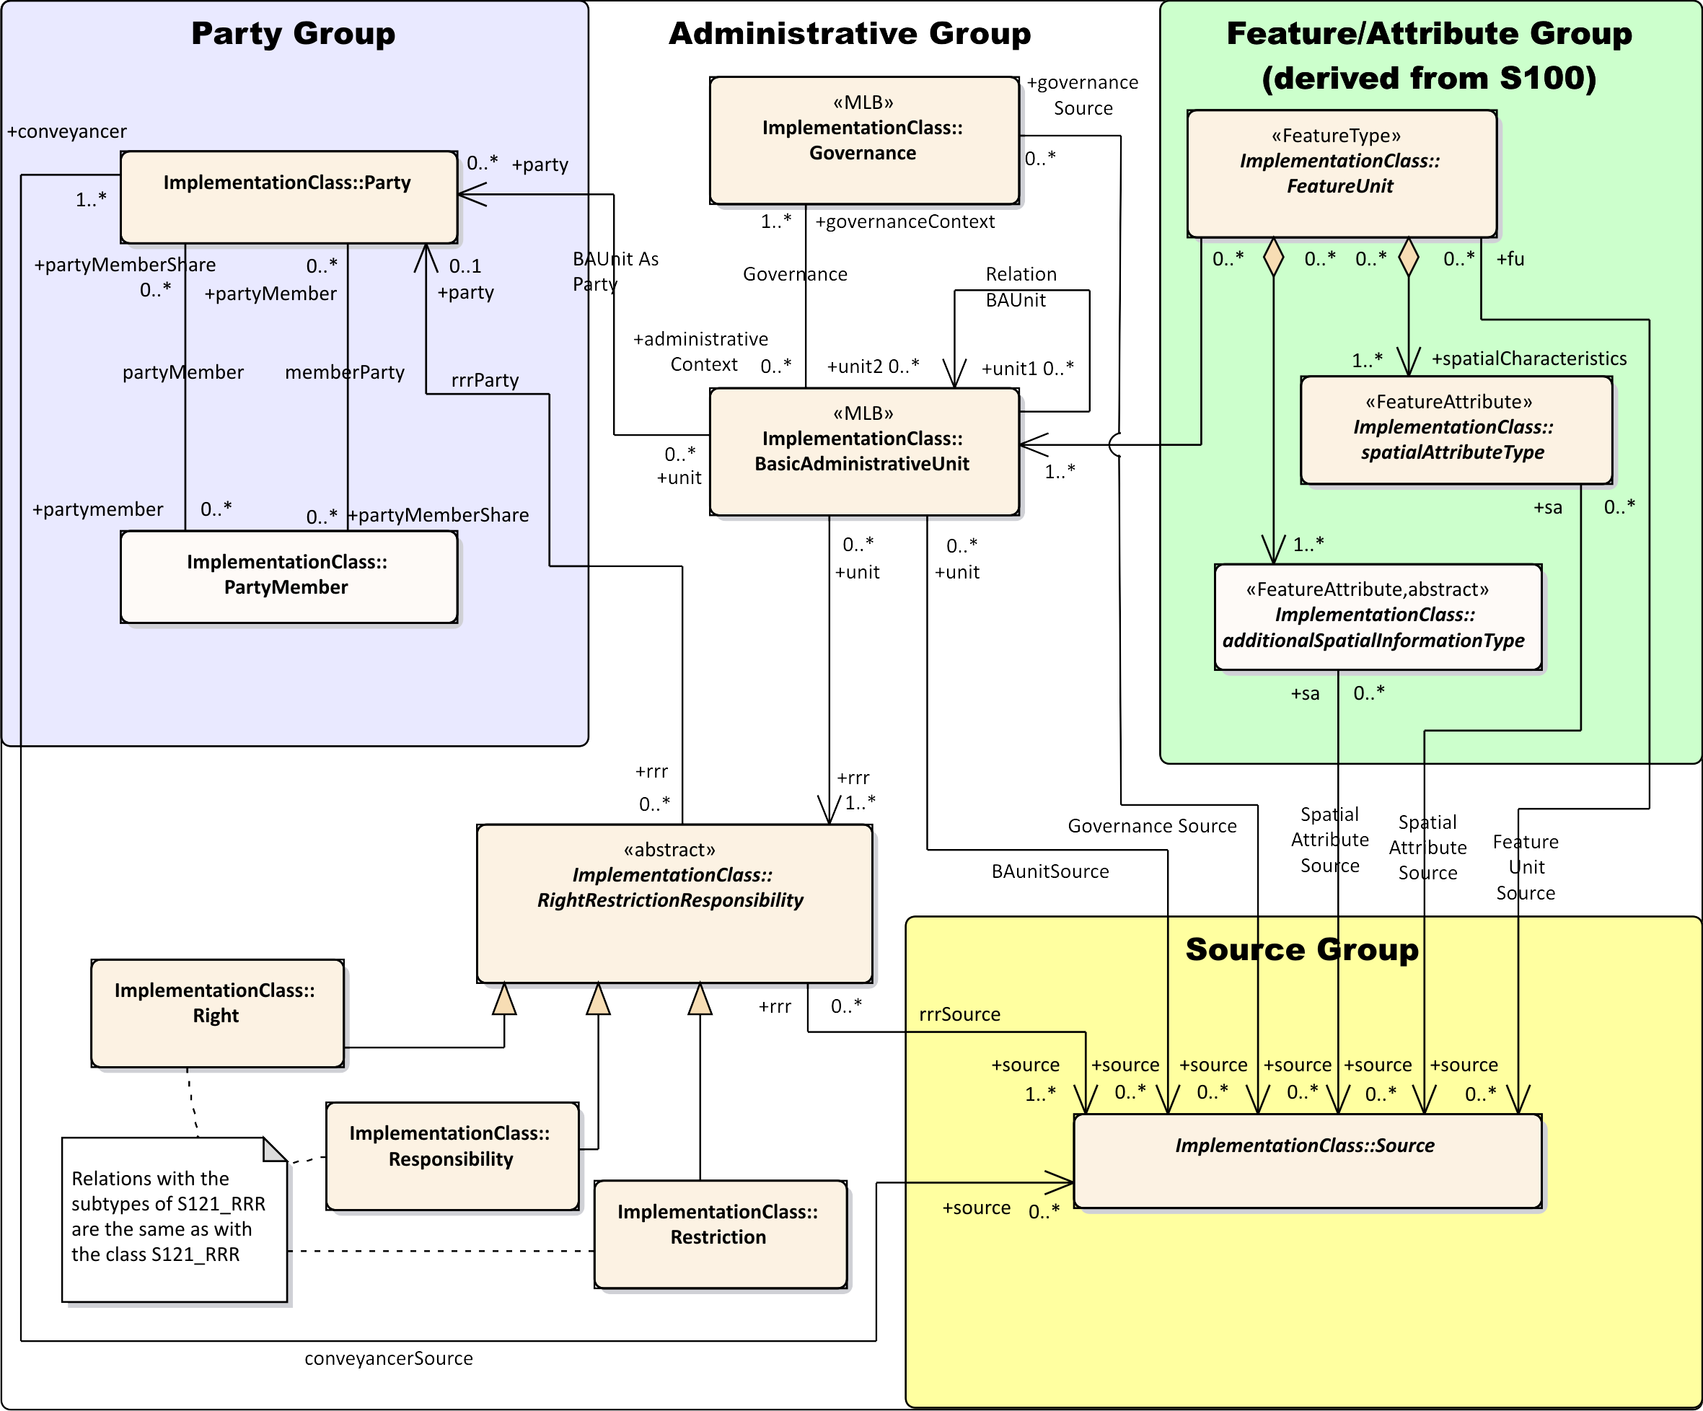

*Figure C-14 – S-121 Implementation Model*

Page intentionally left blank

1. Bibliography

**(Informative)**

1. IHO S-100 IHO Universal Hydrographic Data Model (June 2015)
2. ISO 3166-1:1997 - Codes for the representation of names of countries and their subdivisions,
3. ISO 19101:2003 - Geographic Information – Reference model,
4. ISO 19103:2003 - Geographic Information – Conceptual schema language,
5. ISO 19107:2003 - Geographic Information – Spatial Schema,
6. ISO 19110:2005 - Geographic information – Methodology for feature cataloguing,
7. ISO 19115:2003 - Geographic information – Metadata
8. ISO 19128:2005 - Geographic information – Web map server interface,
9. ISO 19131:2007 - Geographic Information – Data product specifications,
10. ISO 19136:2007 - Geographic Information – Geography Markup Language,
11. ISO 19142:2010 - Geographic information – Web Feature Service
12. NIMA Technical Report TR8350.2 Department of Defense World Geodetic System 1984, Its Definition and Relationships with Local Geodetic Systems, Third Edition, National Geospatial-Intelligence Agency.
13. OGC Catalogue Service for the Web <http://www.opengeospatial.org/standards/cat>
14. OGC (Keyhole Markup Language) KML 2.2 Document 07-147r2 <http://www.opengeospatial.org/standards/kml>
15. EPSG Geodetic Parameter Registry Version: 8.3.3, <http://www.epsg-registry.org/>.
16. WC3 Extensible Markup Language (XML) <https://www.w3.org/XML/>

Page intentionally left blank

1. The normative reference is to the base ISO 19115:2003 metadata standard because IHO S-100 references this version of the ISO standard. The revised standard ISO 19115-1:2014 is backward compatible with ISO 19115:2003 with respect to the metadata elements used in this S-121 Product Specification.
2. In addition to GML, the Google Keyhole Markup Language (KML) has been identified as an encoding.
3. ISO 19152
4. PT_Locale is defined in ISO 19139 and ISO 19115-3 which are the XML encodings for metadata, although the structure allows any text string to include an identifier of language and text in that language..
5. ISO 19152 LADM clause 4.1.13